**Grouping the GitHub repositories and predicting the technology it is built in based on the repository features.**

**By**

**Vinati Gattupalli**

**Title: Grouping the GitHub repositories and predicting the technology it is built in based on the repository features.**

**Background:** A very interesting science paper titled **“ Large teams develop and small teams disrupt science and technology**” has been published in the **Nature**, a British [multidisciplinary](https://en.wikipedia.org/wiki/Multidisciplinary) [scientific journal](https://en.wikipedia.org/wiki/Scientific_journal)-the most recognizable scientific journals in the world, and was ranked the world's most cited scientific journal by the Science Edition of the 2010 [*Journal Citation Reports*](https://en.wikipedia.org/wiki/Journal_Citation_Reports). In this paper the author studied the works of large teams and that of small teams; their tendencies and their characteristics while working in science and technology. In this paper the author studies the team sizes in three different categories of science and technology, they are articles, patents and software. To study the trends of team sizes in software, the author has collected the data from the GitHub. We have performed Descriptive Analysis on the GitHub data to understand the trends of team sizes in the GitHub repositories. With the help of the results obtained in this analysis we concluded that there is a huge difference between the number of large teams and small teams in the data collection, leading to bias in the data analysis Process, 90% of them are solo authored repositories, only 0.2% have 10 or more contributors.

**Introduction:** In my previous research on GitHub repositories, I have considered all the repositories that are in GitHub from 2011 to 2014. GitHub could contain various types of repositories which may or may not contribute to the software. It is very important to identify these repositories and not include them for the team size analysis corresponding to software. Therefore, we need to filter the repositories useful to us removing all the student project and non-useful repositories.

**Statement of the project problem:** GitHub contains various types of repositories which may or may not correspond to individual projects and also, they could correspond to different types of software languages. Each repository will a have a purpose and could be different from one another. It is very important to understand the trends and characteristics of the repositories based on which we can filter the repositories and classify them into technology classes.

**Related works and publications:**

<https://pdfs.semanticscholar.org/a1fd/be4561911b7856d8f2ef9c6103fce9066d6a.pdf>

<https://towardsdatascience.com/clustering-on-mixed-type-data-8bbd0a2569c3>

<https://datascience.stackexchange.com/questions/22/k-means-clustering-for-mixed-numeric-and-categorical-data>

<https://www.kaggle.com/questions-and-answers/56486>

**Objectives of the study**:

1.To understand the trends of the GitHub repositories.

2.To explore the similarities and dissimilarities among the GitHub repositories.

3.To identify different groups based on purpose of creation of repositories.

4. To predict the technology on which the repository was built in.

4. To filter the repositories and use the required categories for further research on team sizes.

**Implementation methodology:**

**Data Extraction**

We do-not have a data set available directly, we need to extract the data from the GitHub. To cater this need, we have a public API provided by data.org. This API enables us to download the timestamped data from the GitHub, we can use this API by passing the date attributes as range such as the year range, month range, day range and hours range. The API follows the below format.

[https://data.gharchive.org/{Year-range}-{month-range}-{day-range}-{hours-range}.json.gz](https://data.gharchive.org/%7bYear-range%7d-%7bmonth-range%7d-%7bday-range%7d-%7bhours-range%7d.json.gz)

I am interested in collecting the data from April 1st, 2014 1 hour to April 30th ,2014 23 hour. So, we will be passing these parameters to construct my API URL. I have split my URL as follows:

url_start="https://data.gharchive.org/"

url_year_month="2014-04-"

day =range(1,31)

hour=range(1,24)

url_ext=".json.gz"

url=url_start+url_year_month+str(i).zfill(2)+"-"+str(j)+url_ext

**Extraction Methodology:**

When we hit the API, based on the time range passed as parameters there are files downloaded where each file corresponds to one-hour data. That implies if we want to get GitHub data for one day, there will be 24 files downloaded that contain data for the corresponding time stamps ( 1 hour to 24 hours) during that day provided.

Considering our time period, it is not a good idea to download all the files at once. So, we will be handling these files one by one and process them as they come.

**Details of Each Data File:**

* Every data file is in Gzipped format, we need to Ungzip it to get a file that can be viewed as a .json file
* The data file contains transactional data of GitHub that corresponding to that particular hour.

**Transactional data**: All the actions performed by the users on the repositories such as push, pull, created etc are given as transactional data of github.

* The file is in .json format but it is not one json object, this file contains a list of JSON files which are individual transactions from the user.
* The size of each file could range from 22 MB to 50 MB depending on the transactions happened that day.

**Processing of data files**

* Read the response of the file using **sessions** module in python.
* Ungzip each file that is in Gzipped format using **gzip** module in python.
* Write the response of ungzipped file into a temporary file.
* Split the content of the file with every new line ("\n").
* We will be getting a list of JSON objects.
* Store all these JSON objects as a list of dictionaries.

**Processing of each JSON string**

Given below is the example format of a JSON string:

{"created_at":"2014-04-01T15:04:48-07:00","payload":{"shas":[["75514ed07d567374fd3160c9dc249e7107dfe7d0","75cb6d43abfcef995279c35980941b7824c56e95@live.co.uk","new login pages and working profile","mwhammond",true]],"size":1,"ref":"refs/heads/newfrontpage","head":"75514ed07d567374fd3160c9dc249e7107dfe7d0"},"public":true,"type":"PushEvent","url":"https://github.com/mwhammond/expert/compare/a15ca534b8...75514ed07d","actor":"mwhammond","actor_attributes":{"login":"mwhammond","type":"User","gravatar_id":"1d8e40017dce79956c7956a7577020ca","email":"da39a3ee5e6b4b0d3255bfef95601890afd80709"},"repository":{"id":18045519,"name":"expert","url":"https://github.com/mwhammond/expert","description":"","watchers":0,"stargazers":0,"forks":0,"fork":false,"size":1592,"owner":"mwhammond","private":false,"open_issues":0,"has_issues":true,"has_downloads":true,"has_wiki":true,"language":"Ruby","created_at":"2014-03-23T15:46:53-07:00","pushed_at":"2014-03-31T15:37:08-07:00","master_branch":"master"}}

* The JSON string is hierarchical, it has a lot of JSON objects within the JSON objects.
* Remove unwanted nodes and collect only the required nodes. (I have removed payload node because I don’t need any information from it).
* Flatten the JSON object and convert it into a data frame by using json_normalize method in python from JSON module.
* Our strategy is to convert all the JSON objects to dataframe to load them into mysql database.

**Data Storage:**

We will be storing all the data in a relational database, MSQL. To interact with this database we will be using **SQLAlchemy** in python. This lets us load the data-frame into **mysql** database directly and we can also read from the database in a pythonic way instead of the traditional queries.

<https://towardsdatascience.com/sqlalchemy-python-tutorial-79a577141a91>

I created a data base named gitclass and stored all the data collected from April 1st 1 hour 2014 to April 30th 23 hours in the table named git_info.

**Details of Data collected in MySQL:**

* There are about 10,396,489 rows of data and 588 columns of the data available from April 1st to April 30 2015.
* We collected 10,396,489 rows of data and 35 columns out of 588 columns that are relevant for our analysis.

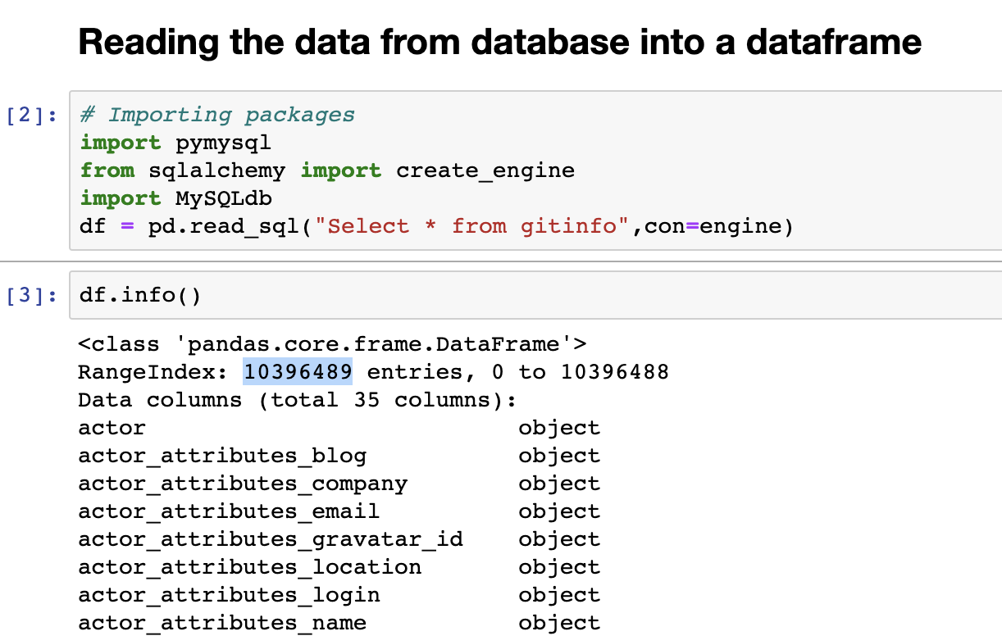

* Out of these 35 columns, we will be keeping the columns related to repositories only which are 22.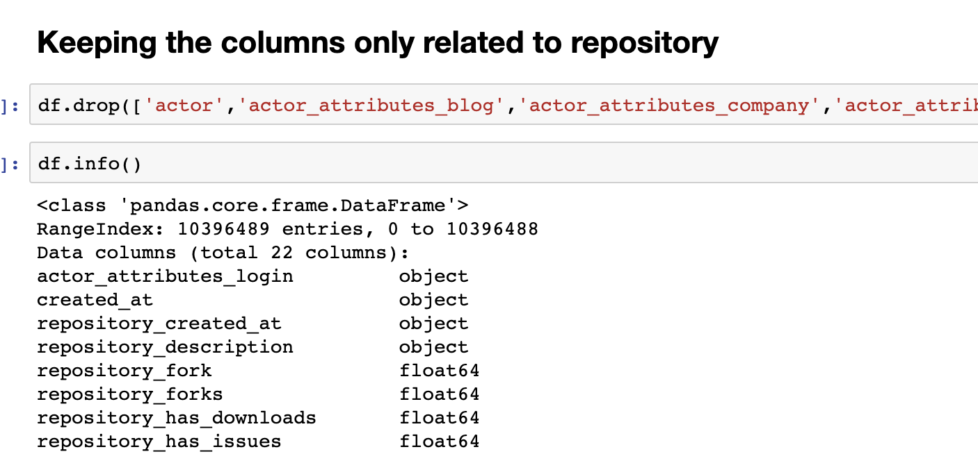
* We know that the data we have is transactional data, therefore there will be a lot of redundant rows containing the same repository information.
* We are keeping only the recent transactions on the repository and storing this data in a table named gitinfo_repo in gitclass database.
* Finally, the shape of our data retained is 719714 rows and 21 columns.

**Data Description**

There are 21 features in the data. Below are their descriptions.

**repository_created_at**: The timestamp which the repository was created.

**repository_description**: The description written by the creator about the repository.

**repository_fork**: Gives the information if the repository is a fork or not.

**repository_forks**: The number of forks to a repository

**repository_has_downloads**: States if a repository has downloads or no.

**repository_has_issues**: States if a repository has issues or no.

**repository_has_wiki**: States if a repository has wiki or no.

**repository_homepage**: States if a repository has homepage or no

**repository_id**: The repository Id of the repository.

**repository_integrate_branch**: Gives information about the branch integration of the repository.

**repository_language**: The technical language of the repository

**repository_master_branch**: Gives information about the master branch of the repository.

**repository_name**: The name of the repository

**repository_open_issues**: The number of open issues the repository has.

**repository_organization**: The organization the repository was made for.

**repository_owner**: The owner of the repository

**repository_private**: States if the repository is private

**repository_size**: The size of the repository.

**repository_stargazers**: GitHub allows users to star a repo to bookmark it. This gives the number of

stargazers a repository has.

**repository_watchers** : Watchers are Github users who have asked to be notified of activity in a

 repository, but have not become collaborators. Watching a repository is similar to following a

feed to see changes. This gives the count of the repository_watchers.

**Data Pre-Processing**

**Data Cleaning:**

* **Checking the data for any duplicate records** and dropping them. In our data, there are

No duplicate records.

* **Checking for any special characters** in repository name column. There are no special characters in our nominal data.
* **Understanding the data types** of our features.

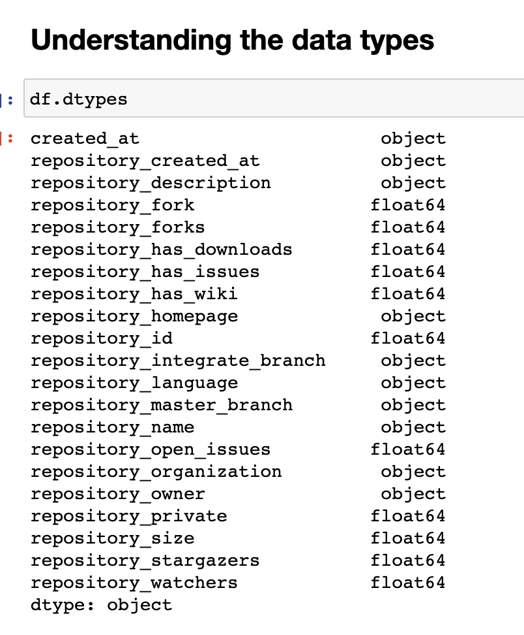

We can see there are two data types in our data from the pie-chart given below.

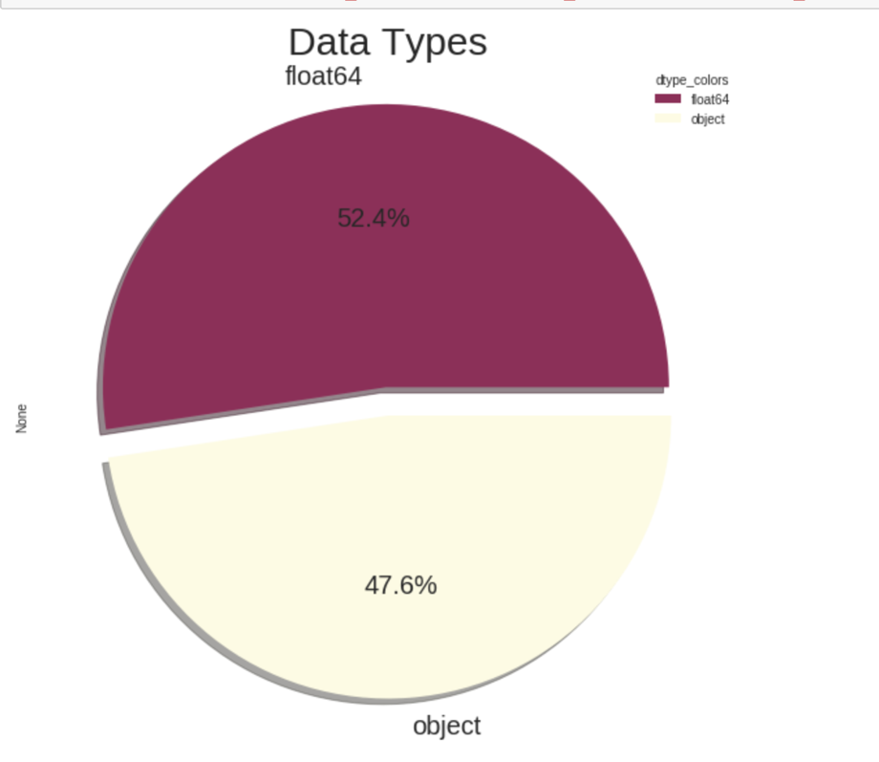

**Detecting Null values:**

### We are using a heatmap to display the null values in our data. After observing the heatmap below, From the above heatmap we can observe that repository_homepage, repository_integrate_branch and repository_organization has a lot of null values. It’s better to drop those columns.

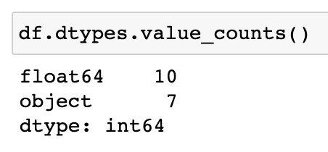

Now we have 10 float features and 7 object type features.

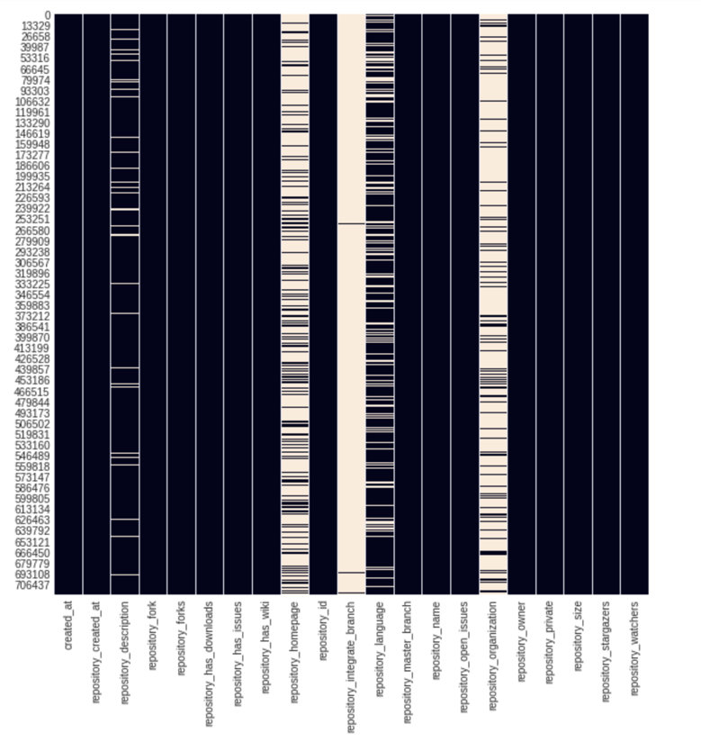

**Detecting the null values data type wise:**

We found that there is one null value for each of the float type feature.

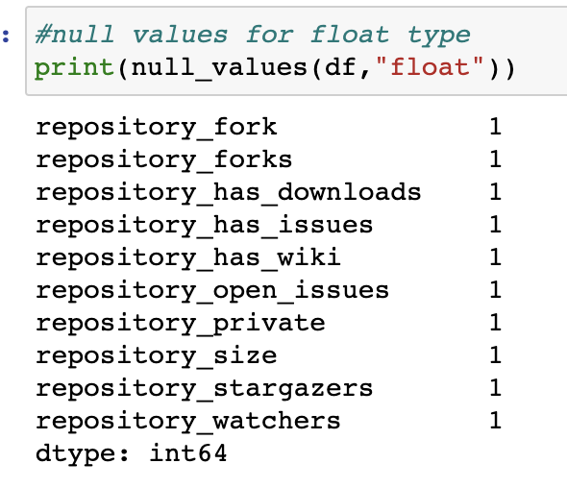

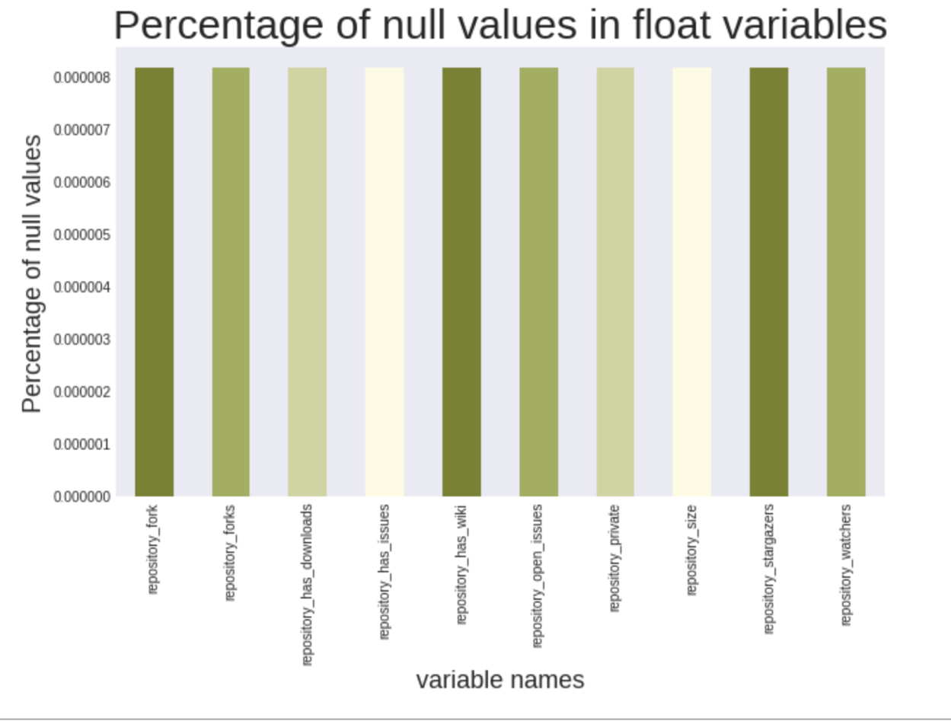

It is a very less percentage we can delete them or replace it with a median value. We chose to replace them with median.

**Detecting null values in object type features:**

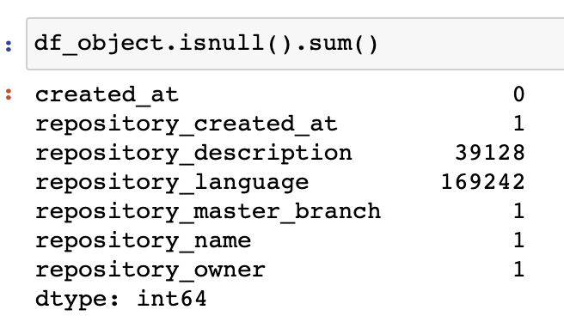

**We can also see the percentage of missing values for each features among the records in the screenshot below.**

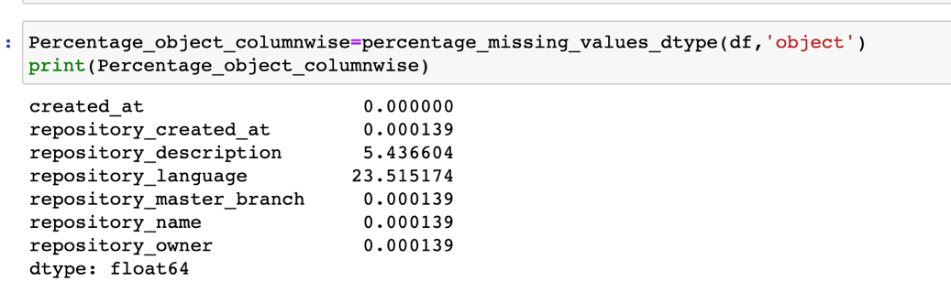

We can see in the below pie-chart that repository language has majority of the null values, second comes the repository description and rest all have one null value.

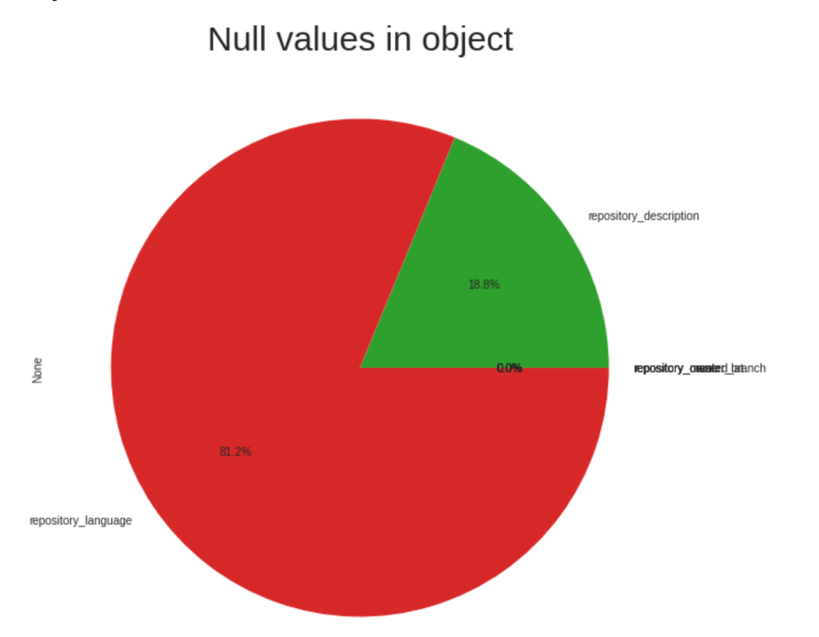

**Handling the null value in object type feature:**

* We choose to handle the missing object-type data which can be categorical such as repository language etc by replacing them with their respective modes.
* Now we need to handle null values for text description.
* We choose to delete the null text description values.
* Now we donot have any null values in the object type features.

**Exploring the float type features**

**Converting the type of float features**

All the float features are mostly the count values or Boolean values so we can convert them into int.

**Getting the unique value counts for each of the int variables**

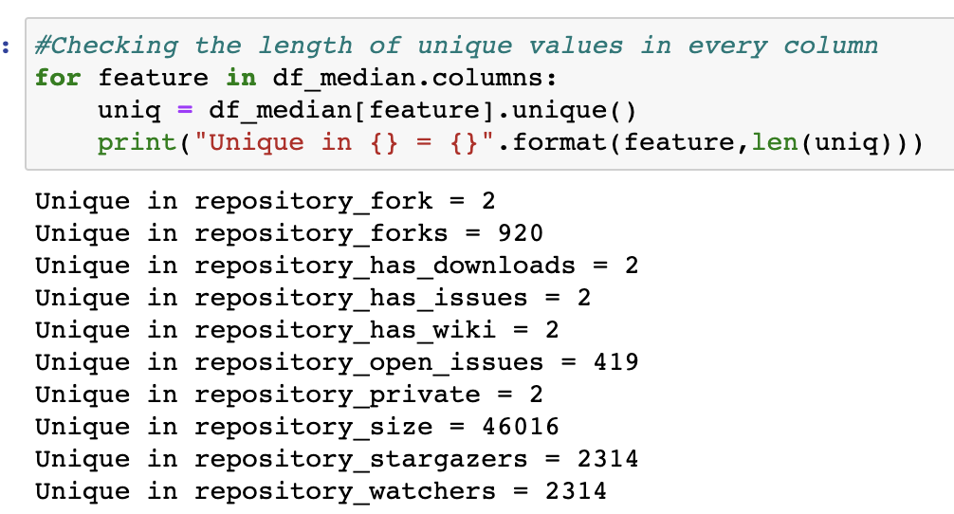

As we can observe from above repository_fork, repository_has_downloads, repository_has_issues, repository_has_wiki, repository_private all these are Boolean variables having values 0 and 1.

So, 5 out of 10 int data types are Boolean values having 0 and 1.

**Exploring the repository_private feature:** All the values in repository_private has 0 value in its records. It is redundant to have the same valued feature, because there is no variance. So, I am deleting this feature.

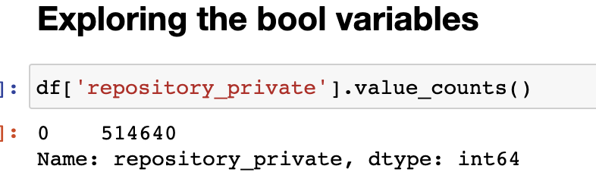

**Exploring the non-bool variables ie the remaining 5 int variables:**

**As we can see when we plot histograms on these variables, all the values for them fall in a single bin ie they are not continuous values. They are the discrete values and have to be treated differently in our data. They can be treated as categories also. Let’s decide what to do with them in the next stages.**

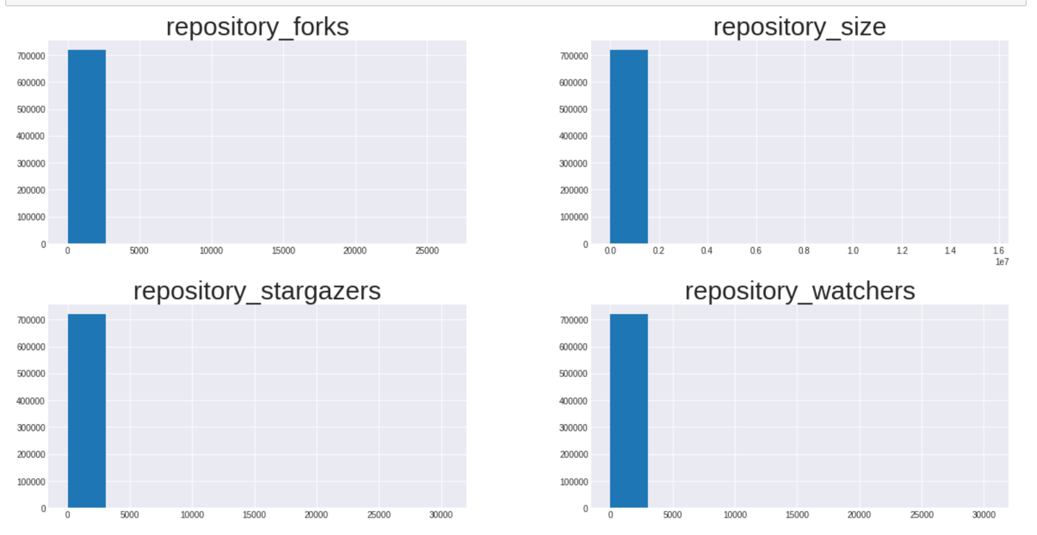

**Dealing with repository_owner and repository_name features:**

I felt that both have same data, so I wanted to apply correlation and check. As we can see in the below screenshot, the correlation is obtained as 1 which means they are highly correlate and both contains same information. So I chose to drop one of them which is repository_owner.

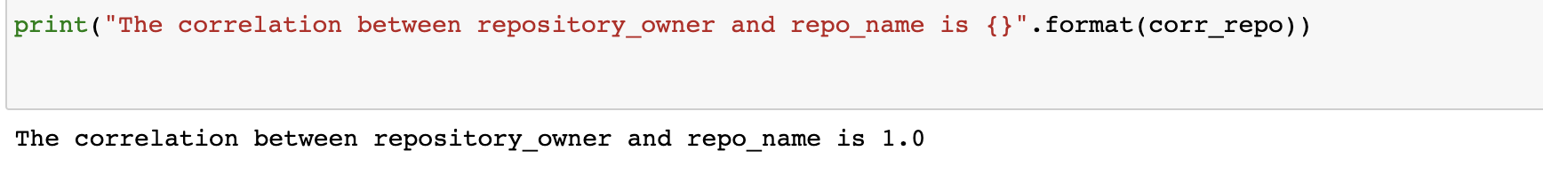

**Processing the target variable**

Our target feature in the project is the repository_language. Let’s explore repository_language. It consists of more than 80 unique values. Having so many target classes can be difficult for us to deal with and also inefficient. So, let us select the top 7 languages in our data as classes.

The top 7 languages in our repositories are:

**['JavaScript', 'Java', 'Python', 'PHP', 'Ruby', 'CSS', 'C']**

We can name all other repository languages other than these as other. Thus, forming another class.

**Now we have a total of 8 categories in our target variable, repository_language which are the target classes.**

In the below bar chart, we can see the number of repositories belonging to each language class.

* JavaScript has the top number of repositories that have used the language.
* Then comes other language repositories succeeded by Java, python, PHP, CSS.
* The language used by least number of repositories in our data set is C.

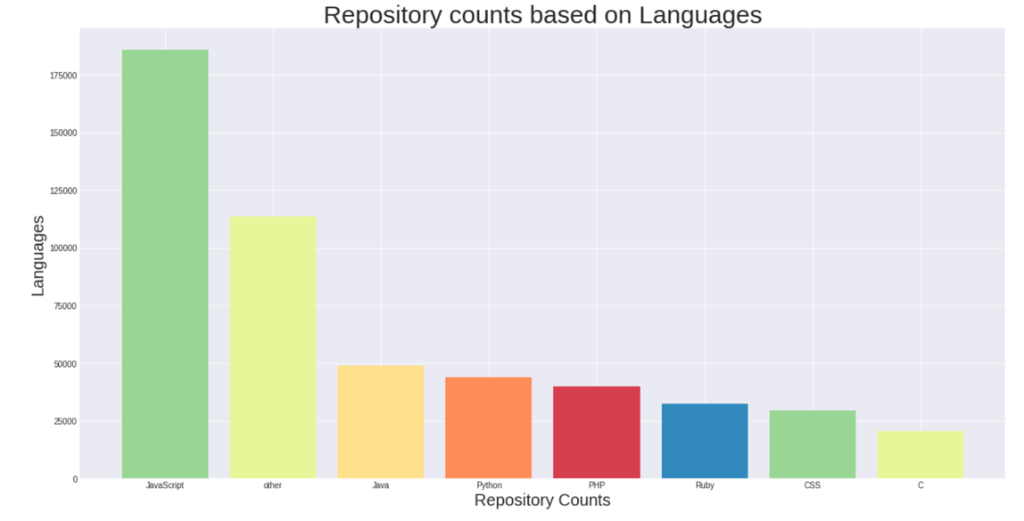

**Exploring the feature repository_master_branch:**

The unique value counts for the repository_master_branch are given below.

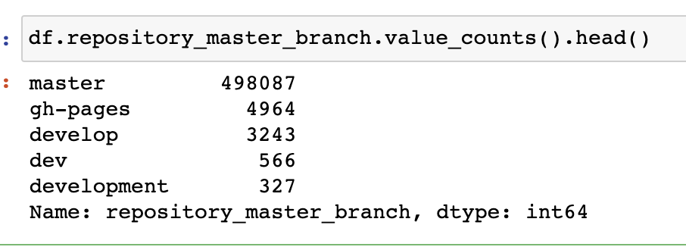

As we can see dev, development and develop all the three categories are same but are given with different names. Merge all of them and make it a single category dev.

**Checking out the remaining columns:**

The remaining columns fall into three categories- discrete int, Boolean , categorical, nominal and text. There are 14 columns in total. They are 'repository_created_at', 'repository_description', 'repository_fork', 'repository_forks', 'repository_has_downloads', 'repository_has_issues','repository_has_wiki','repository_language','repository_master_branch', 'repository_name', 'repository_open_issues','repository_size', 'repository_stargazers', 'repository_watchers'.

**Text-** repository_description

**Nominal** - repository_name, repository_created_at

**Boolean**- repository_fork, repository_has_downloads, repository_has_issues, repository_has_wiki

**Categorical**- repository_master_branch, repository_language

**Discrete-int-** repository_forks, repository_open_issues, repository_size, repository_stargazers, repository_watchers.

From the above we can understand that we have a mixed type of data and we need to handle each type differently.

**Feature Selection:**

I have used **Chi2 test** for feature selection. I have applied it on all my numeric features.

The below screenshots show the p-values obtained for all the numeric features we have fitted. The p-values are all below 0.05 , so all of them are correlated with the target feature.

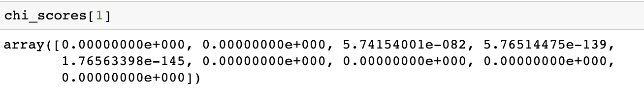

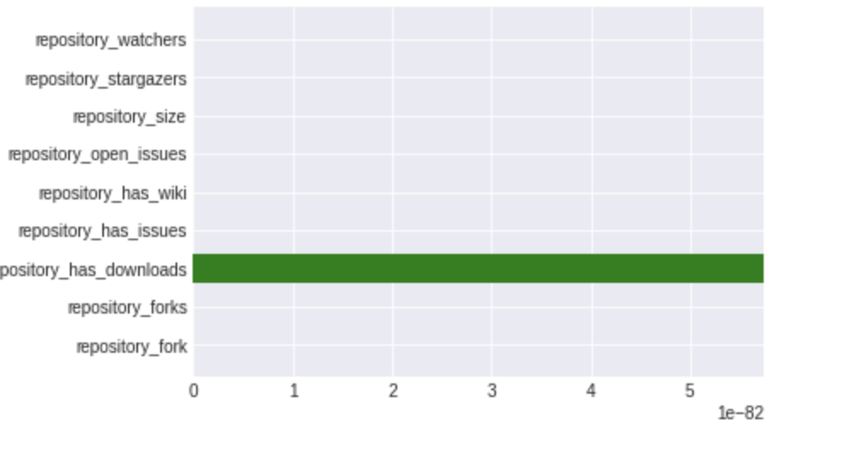

By using chi2 we found out that all the numeric features are associated with the target variable so we are retaining all of them.

* In **Nominal variables** we can hold repository_name as reference without using it in the processing and I not to consider repository_created feature for my class prediction.
* In **categorical variables**, we will be holding and encoding repository_language as it is my target variable and I decide to drop repository_master_branch as it has a lot of levels.
* **In Boolean variables,** we will be holding all of them because they are easy to use and they don’t require any processing and can be converted into categories further.
* We have to figure out how to process the **discrete in**t variables and use them for our prediction.

**Feature Engineering**

* **Text pre-processing, analysis and encoding.**
* **Categorical encoding for categorical variables.**
* **Categorical encoding for Boolean variables.**
* **Encoding the discrete variables.**

**Text pre-processing, analysis and encoding**

**Length of the repository description:**

We found the statistics on the number of characters in the repository description.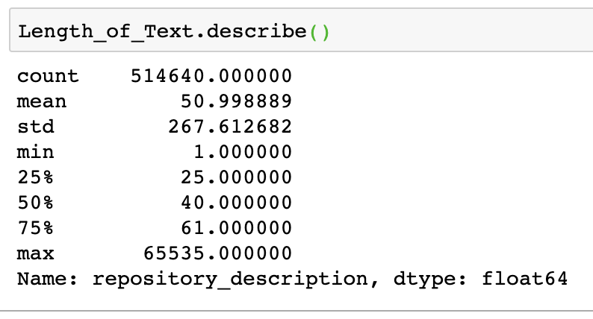

We can also see the histogram plotted for the number of characters.

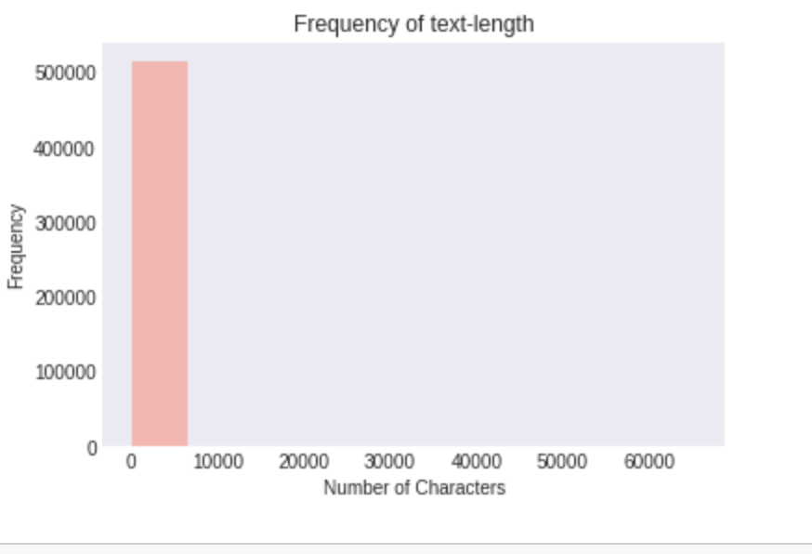

From the above histogram, we can get the following points:

* The lengths of the descriptions are discrete and not continuous.
* Most of the repositories fall in the first bin that is 500 k repositories have lengths less than 10,000 characters.
* Only few have characters beyond that.

**Text Cleaning:**

Cleaning the text involves a lot of steps. For our texts in our data we have done the following:

1. Convert the text to lower case.
2. Remove punctuations and special characters.
3. Remove any numerical data.
4. Remove any white spaces and tab spaces.
5. Remove any white space characters using strip.
6. Remove the one letter words.
7. Our text contains Chinese words, we have to remove them also.
8. Tokenize the text for analysis.
9. Remove stop words from the tokenized text.

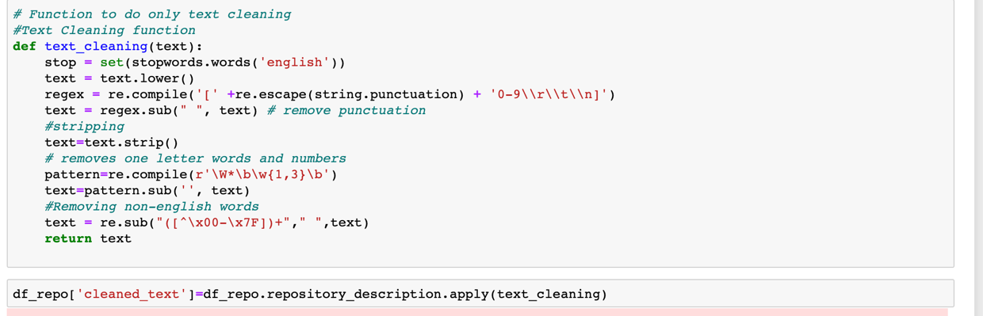

To implement all of these we have written a function and have made a column to hold the respective tokens for the text in the dataframe.

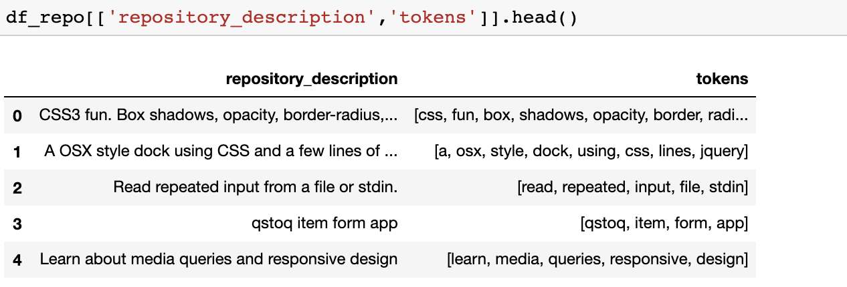

The below are some tokens and their descriptions.

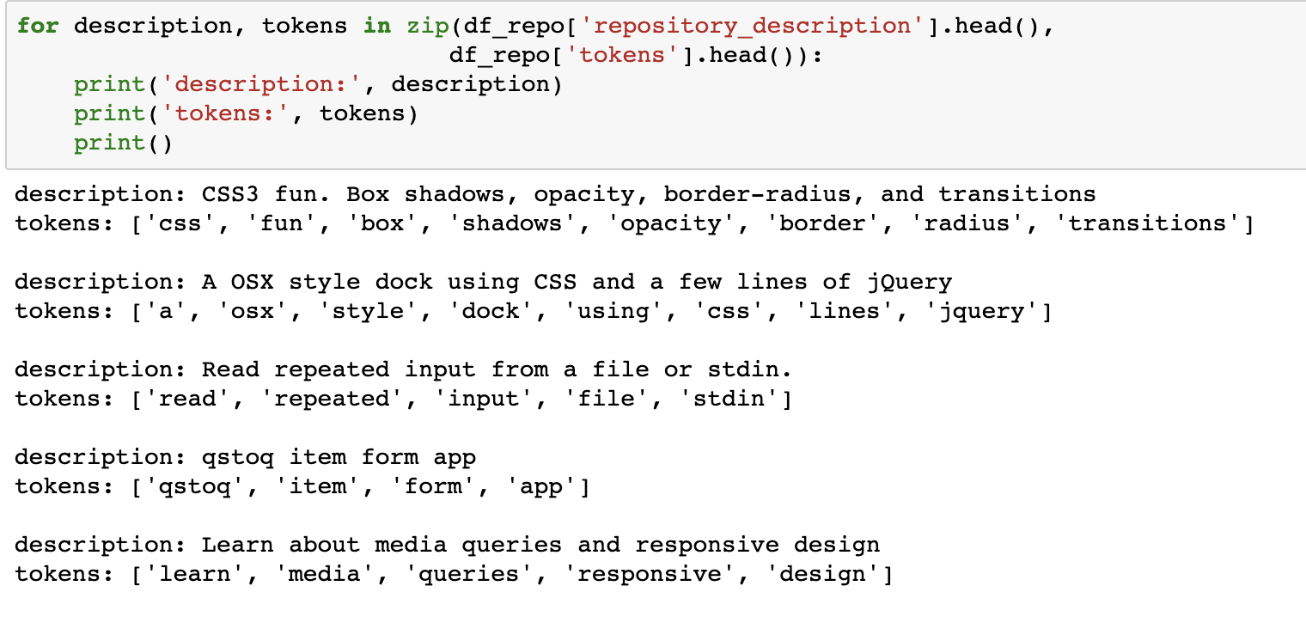

**Exploratory Data Analysis for Text**

**We have made a word cloud to get visual representation of the most common words in our descriptions.**

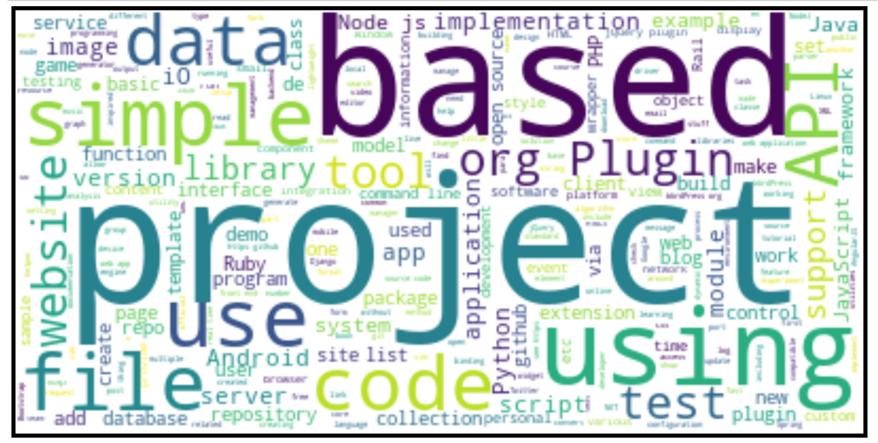

**From the word cloud we can clearly interpret that:**

* Our descriptions for the repositories mostly have the highlighted words in the word cloud.
* Size is directly proportional to the frequency of these words.
* We can say that project is the most frequently occurred word in all our repository descriptions.
* Next comes the words based, using, data, simple, website etc.

**Some word clouds based on languages:**

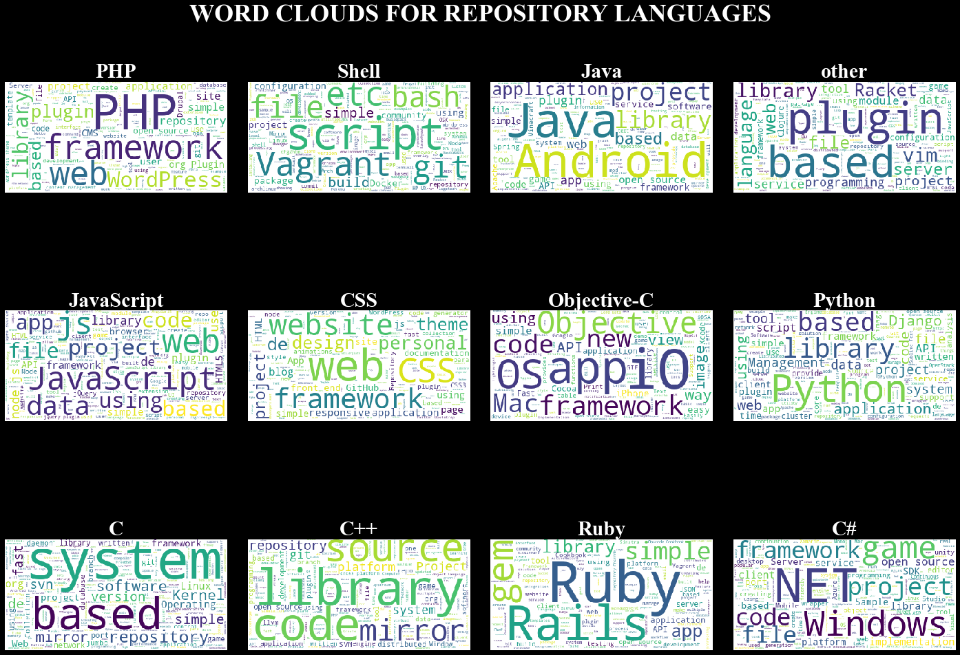

**From the above word cloud we can infer the following for each category:**

**PHP:** The most common words in PHP are **PHP, framework, web, library, wordpress**.

**Shell**: The most common words in shell are **script, git, bash, build, simple, vagrant** etc.

**Java:** The most common words in JAVA descriptions are **JAVA, Android, application, project,app, plugin, library**.

**JavaScript: Javascript, js, web, data, app, file, using.**

**CSS: website, CSS, framework, theme, project, page,blog.**

**Objective-C: app, io, os, mac, framework, objective,new.**

**Python: python, library, data, application, project, script,Django.**

**C: simple, based, kernel, mirror, fast, software, system, game.**

**C++ : library, mirror, source, code, repository,system.**

**Ruby: Ruby, rails, app, gem, library, simple, Application, API.**

**C#: framework, game, .Net, windows, file, open source, platform, SDK.**

The most frequent words in PHP repository descriptions are:

PHP has 50 counts which is the maximum and git has less than 10 counts.

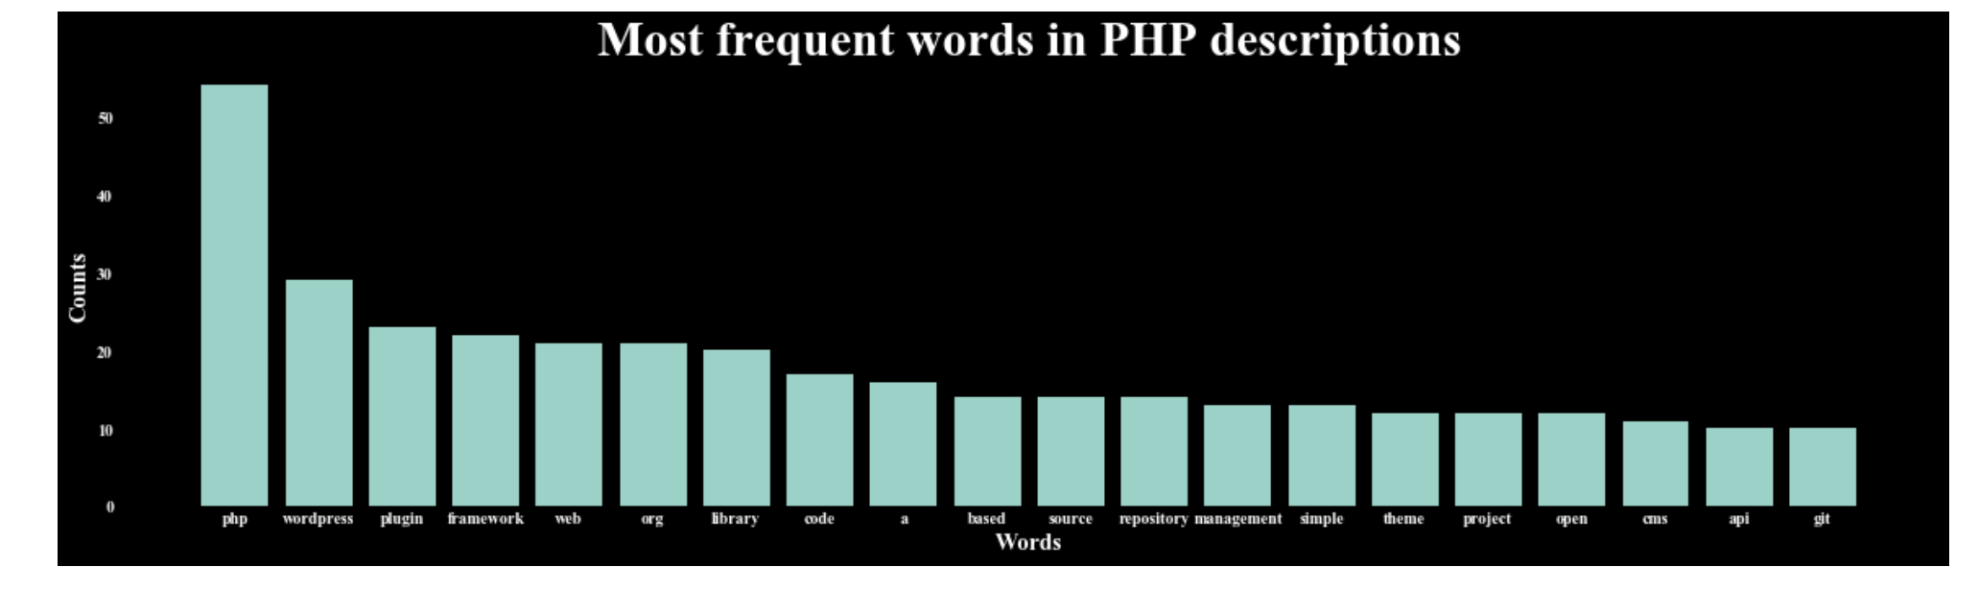

**Encoding the repository_description using TF-IDF:**

**Term Frequency: It is the frequency of a term with respect to the corpus. The number of times a word has occurred divided by all the words.**

We can convert the descriptions into TF-IDF vectors to use it for further analysis.

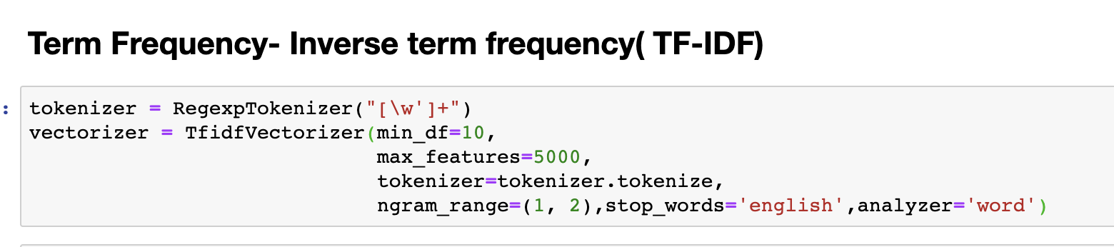

The hyperparameters passed are:

* Min_df – It is the minimum value of document frequency that should be considered.We have passed 10.
* Max_features: The maximum number of features our tfidf vector should be having.We want to get 5000 features from the descriptions.
* Tokenizer: We should pass a tokenizer that tokenizes the text.
* Ngram_range: It is the range of words that can be together. We have passed (1,2) implies that I can have one word features and also two word features.
* Stopwords: I have given stop words as English, so we will not have stopwords such as a, the etc in our features.

From the below screen shot we can see that we have fit our descriptions made as list and transformed them.

* The output we got is a sparse matrix that consists of tfidf values for document and word pairs.
* The shape of the vector is that it has 514,640 rows like our repository description and it is split into 5000 features like we have mentioned.
* We can obtain tf-idf values and also feature names from this vectorizer.

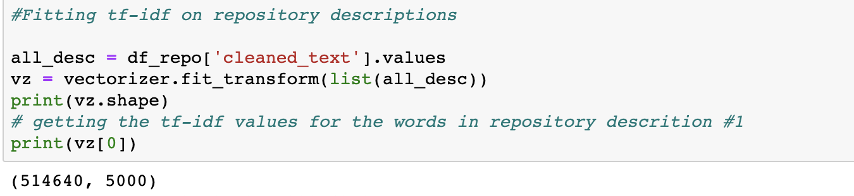

**TF-IDF value gives us the measure of how important a word is to the document.**

**In the screenshot below, we can see the feature names as indexes in a data frame and the TF-IDF values in the ascending order.**

* Project has the least TF-IDF value that means that it is the frequent word in a corpus.
* TF-IDF is the product of TF and IDF scores, higher the tf-idf value rarer the term.

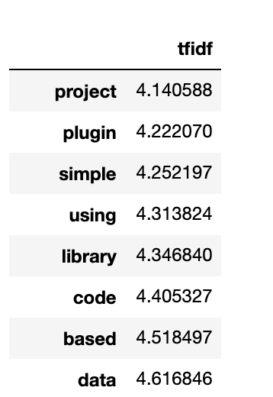

**Dimensionality Reduction:**

We have 5000 features in our data. Reducing the dimensions of our data benefits in decreasing the redundant information and we can have higher variance in reduced features. We have a sparse matrix giving TFIDF values. There are two techniques that can be commonly used for dimensionality reduction.

1. Principal Component Analysis
2. Latent Semantic Analysis.

Both the methods use the same method. They use Singular Value Decomposition. PCA is more feasible if there is a co-variance matrix available but we have sparse data so we will be using LSA.

**Latent Semantic Analysis:**

LSA is implemented in python through a package called truncatedSVD in scikit-learn.

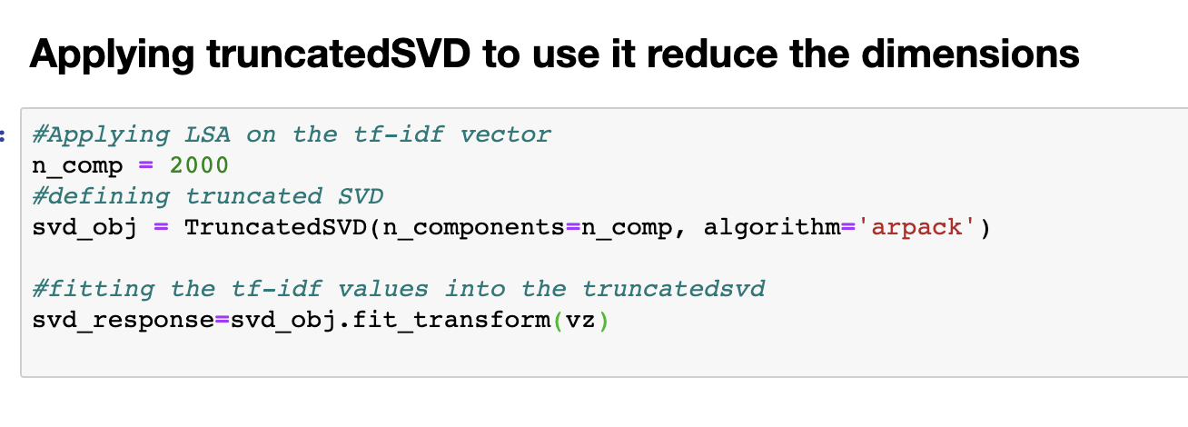

**We have passed the hyper parameters as n_comp=2000 and used the algorithm arpack. With this algorithm we are going to reduce 5000 features to 2000 features.**

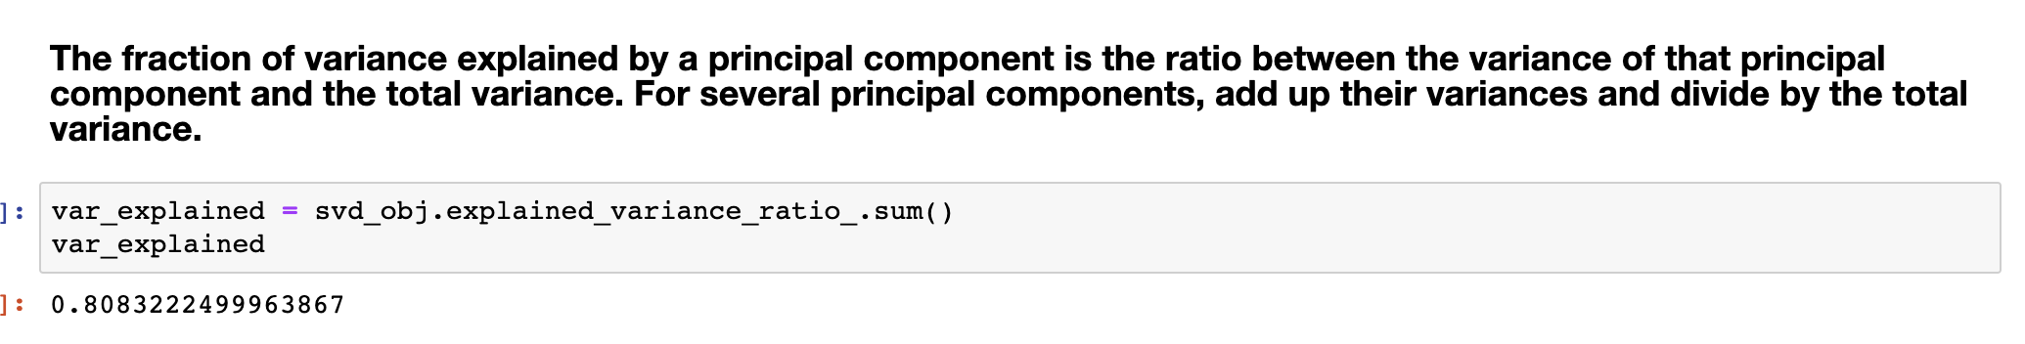

Now our 2000 features have about 80 percent of variance.

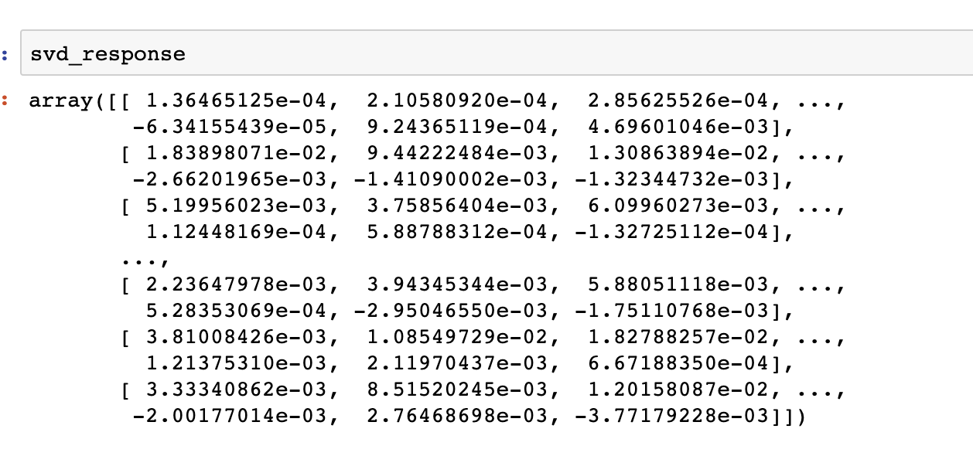

We have all of those in a dataframe for svd:

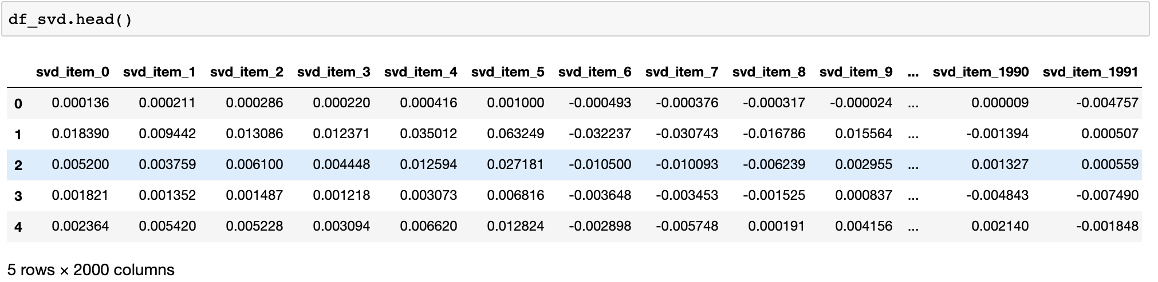

**Visualizing the TF-IDF matrix:**

1. **We will be taking a small sample to plot the tfidf matrix:** Given the high dimension of our tfidf matrix, it is practically a lot time consuming to use the whole data. So, we will take a small sample of our data.

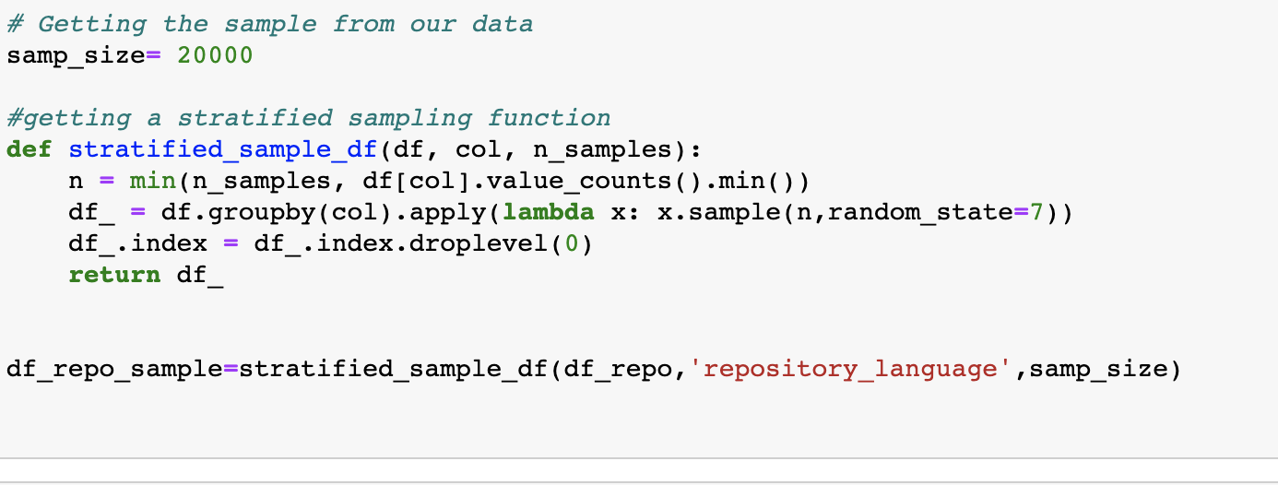

The above screenshot has a function written to get the stratified sample from our data, that has all the repository_languages categories distributed equally in the sample.

1. Apply tf-idf vectorizer on the sample to get 300 features in the vector.

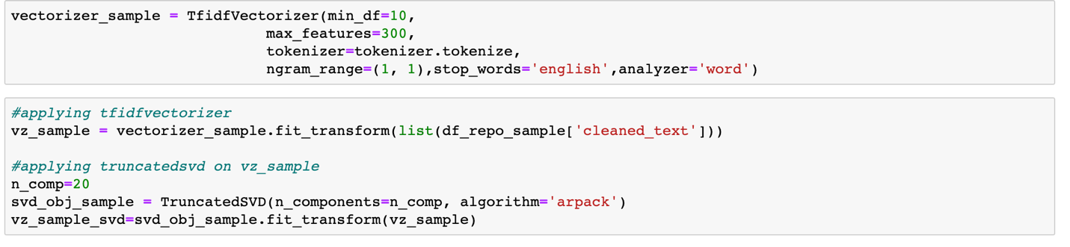

1. **Apply Truncated SVD on the sample and reduce its dimensions:**

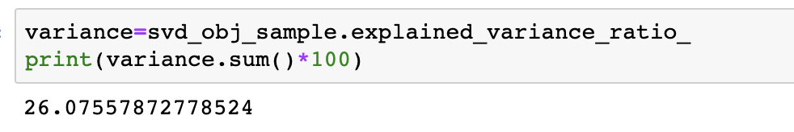

1. **Apply t-sne to reduce the dimensions to 2 or 3 easier for visualization:**

t-sne is a dimensionality reduction technique that is amazing to use for visualization. We cannot use it directly because it takes a lot of time to process, so we use another dimensionality reduction technique.

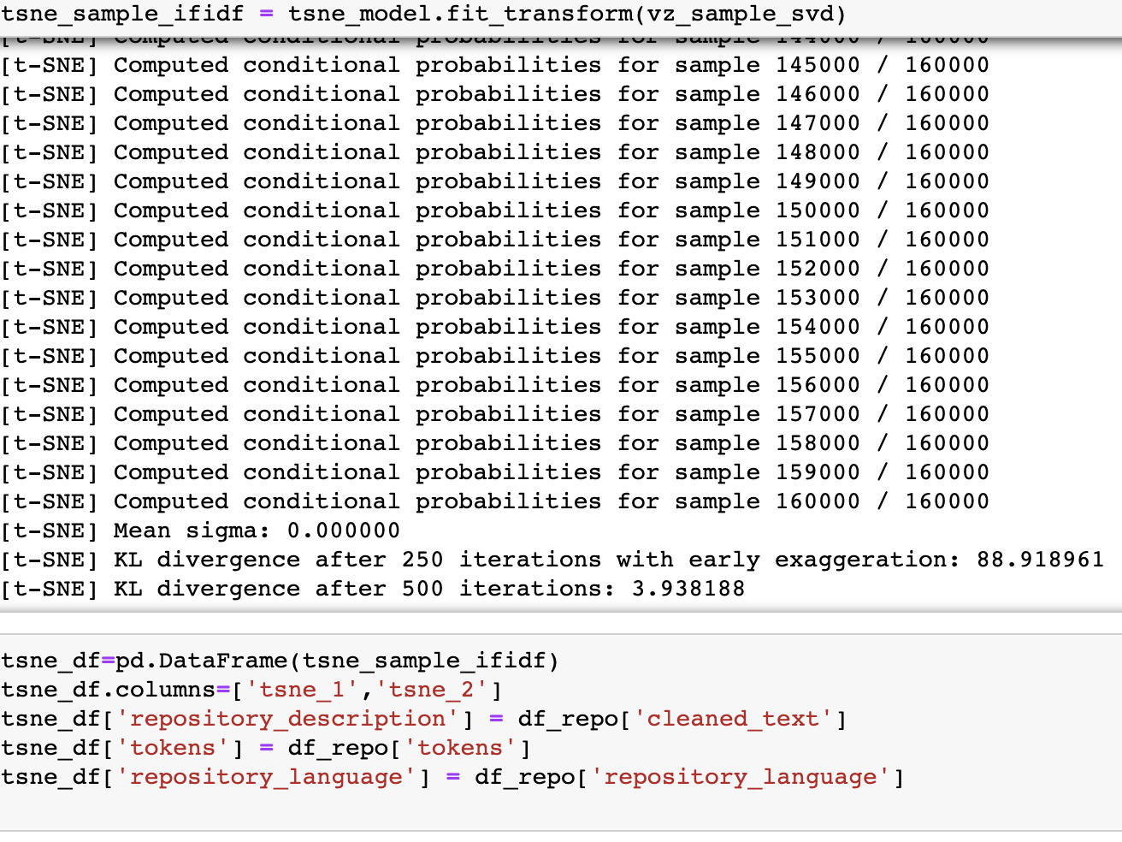

1. **Making interactive Visualization with bokeh:**

Bokeh module in python enables us to do interactive visualizations in Bokeh. We can add tools to the plot to hover, zoom, save, review etc.

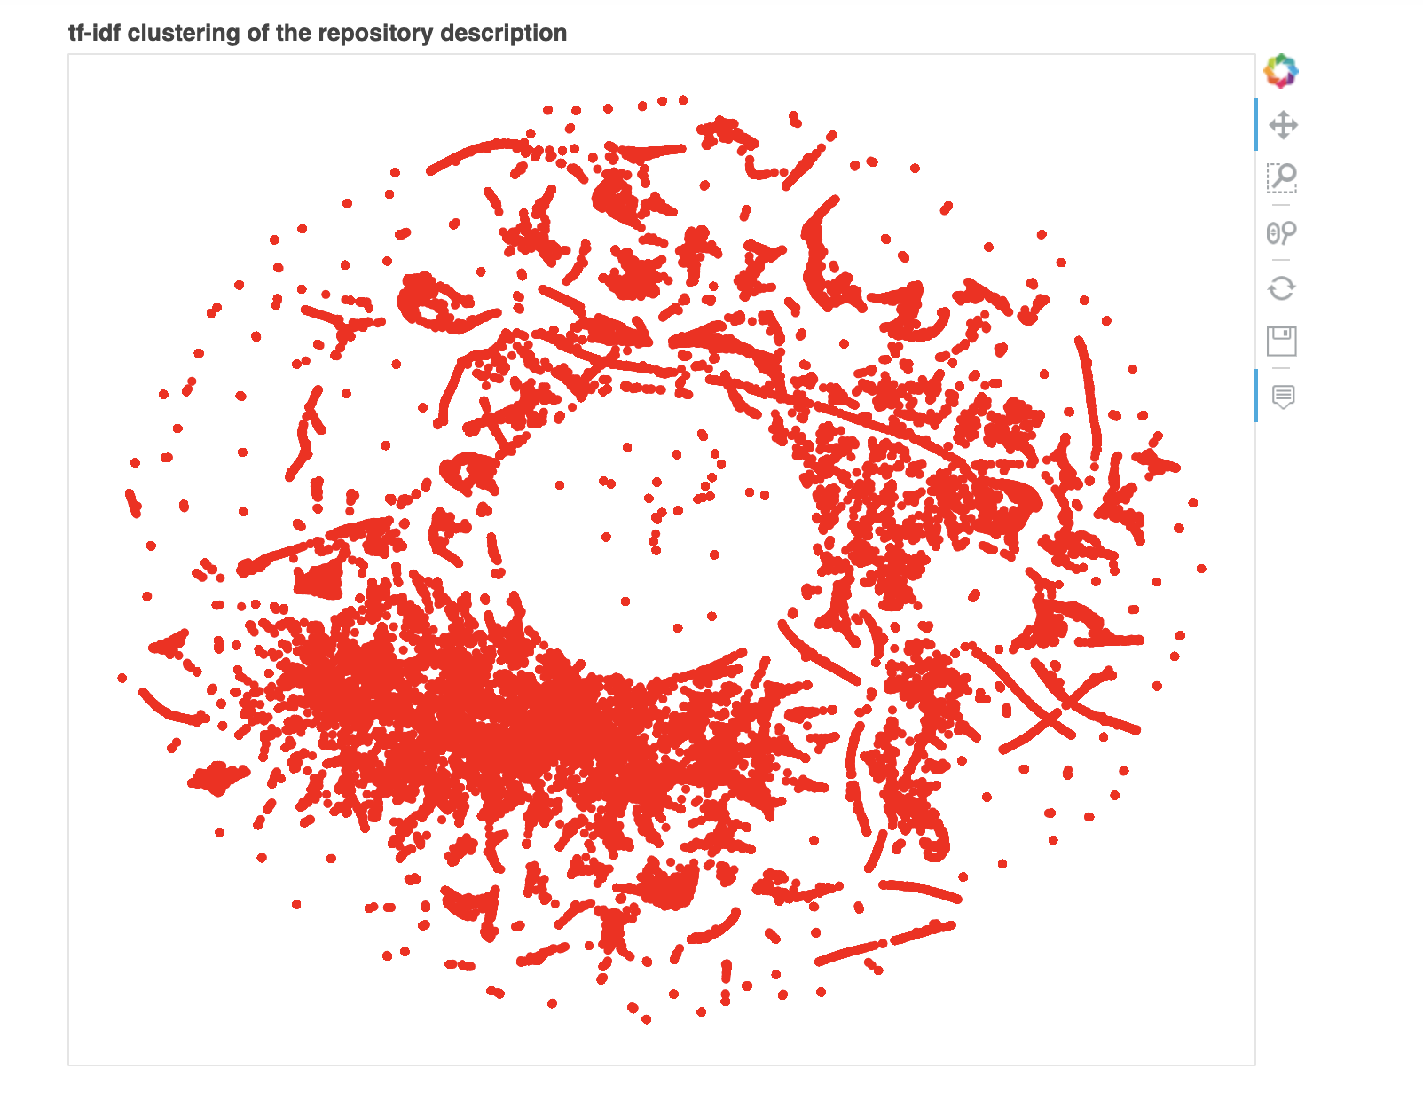

Below is the image while we hover on to the tf-idf plot. We can see details about the plot such as description, tokens etc.

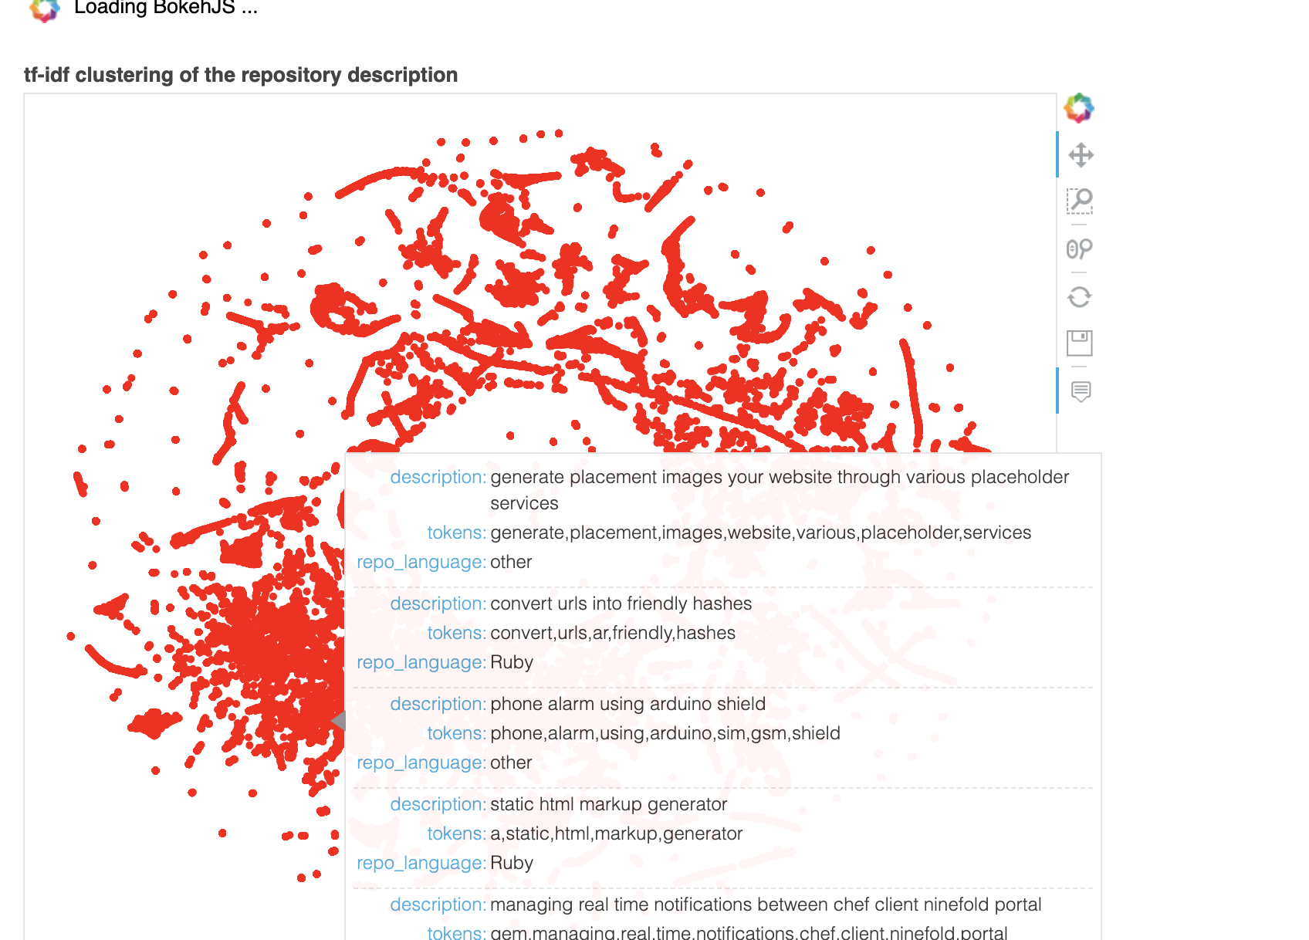

**Clustering on TF-IDF data:**

In order to find the groups within our repositories we will be implemention K-means clustering technique on TF-IDF data. In python, its more feasible to use Minibatchkmeans function to find the clusters because it computes the data as batches and is quick.

**Tuning the hyperparameters in Kmeans clustering technique**:

It is very crucial to choose the correct value for k in k means clustering technique. In order to find the correct value , we follow elbow method. We will be fitting the data for kmeans considering a range of values for k and plotting a graph between the k-value and the distortion of kmeans for that particular value of k. And the point where the distortion decreases rapidly by forming an elbow is the optimum value of k.

We have plotted an elbow graph to check same.

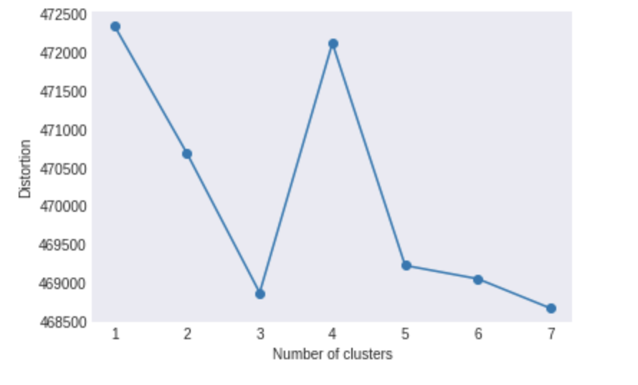

As we can see in our graph the elbow is at 5. So, the optimum number of clusters will be 5.

We will be using this value to fit our data into minibatchkmeans algorithm.

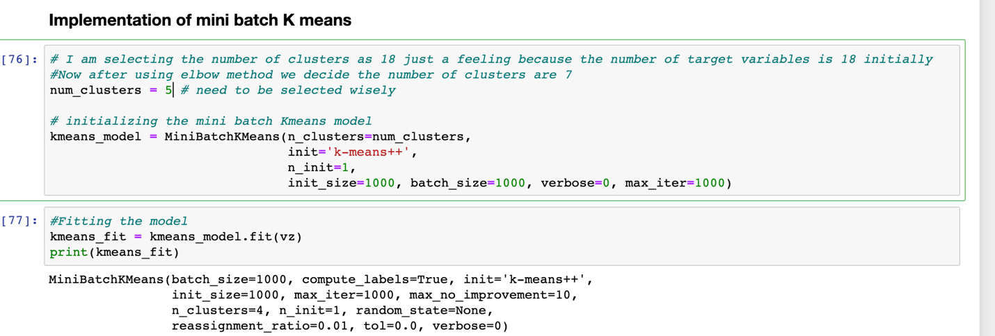

* We get the kmeans distances if we apply transform on our vector. These are the distances from each point to the centroid.
* We get the centroids of the clusters obtained after fitting them
* We can pass our data and predict into which category each of them fall.
* I have made a column on the dataframe to see their corresponding cluster.

**Prominent features that fall in our clusters:**

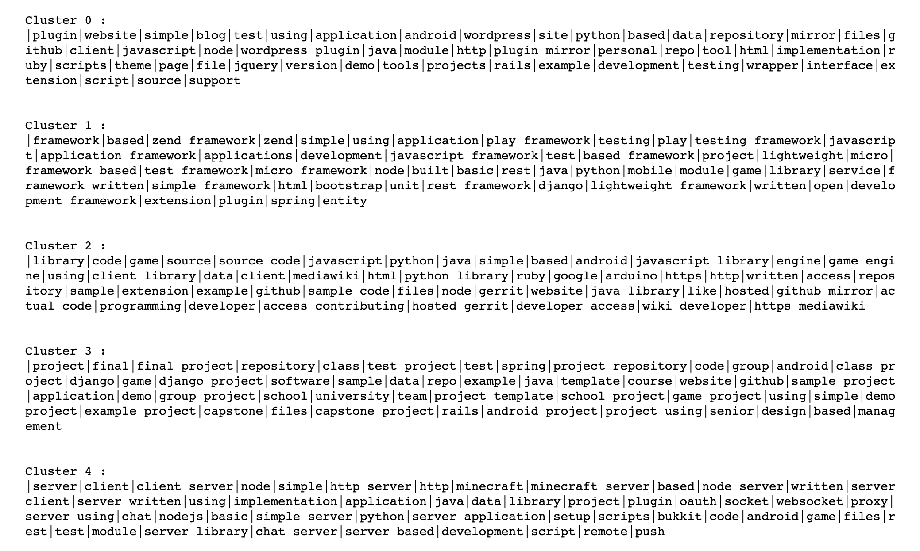

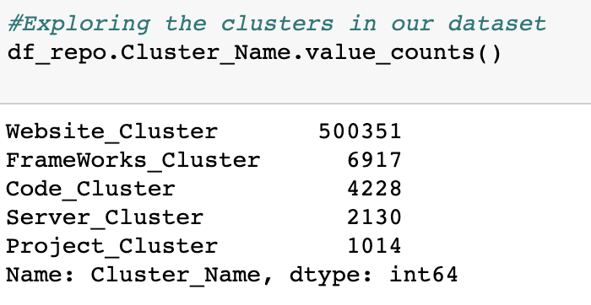

As we can see from the above screen shot, there are 500k repositories that deal with websites and their technologies.

After seeing the cluster contents we can name the clusters as following:

Cluster 0: **Websites and Application Cluster**

This cluster contains information related to the technologies used for building clusters and different key words related to websites

Cluster 1: **Frameworks and Tools Cluster**

This cluster contains different types of frame works, technologies related to the framework and key words for frameworks.

Cluster 2: **Code Cluster**

This cluster contains different key words for code and code storage files such as libraries, files, repositories, source code, mirror etc.

Cluster 3: **Project Cluster**

This is a project cluster, the most important cluster we have been looking for. It has all the types of projects related to class, capstone, academic and group projects.

Cluster 4: **Server Cluster**

This cluster contains different types of server and server based scripts. It has a lot of keywords related to server such as client, remote,setup, socket etc.

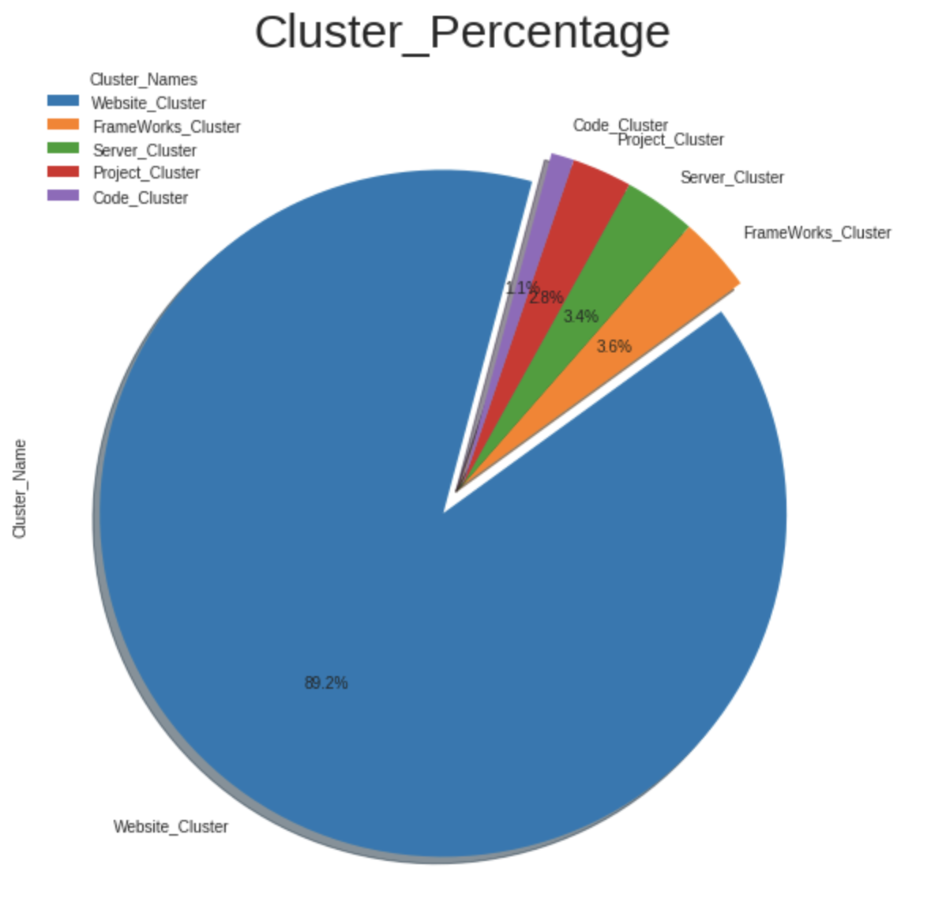

**Visualizing the clusters:**

**We can visualize the clusters obtained by making an interactive plot using bokeh.**

**For this we collected a sample, applied svd and applied tsne to plot the clusters.**

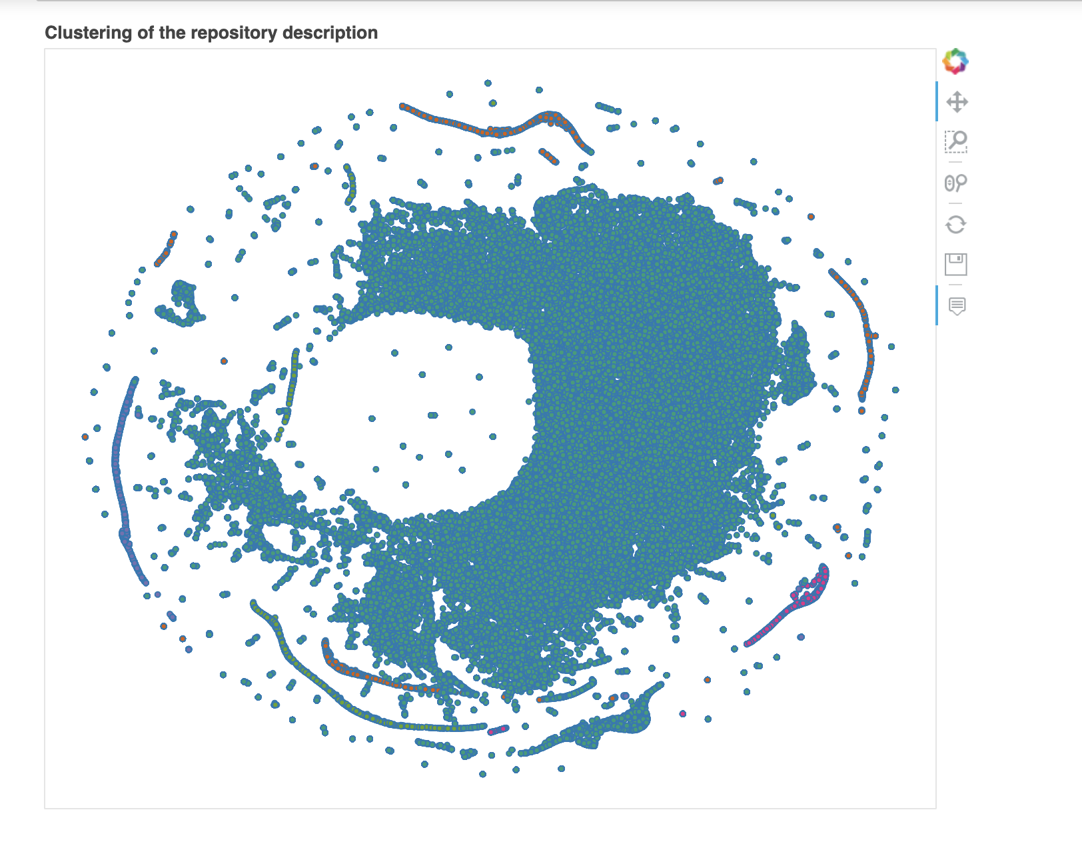

By pointing at the point in the visualization we will know details about the data point like the cluster number, tokens, description, language category etc.

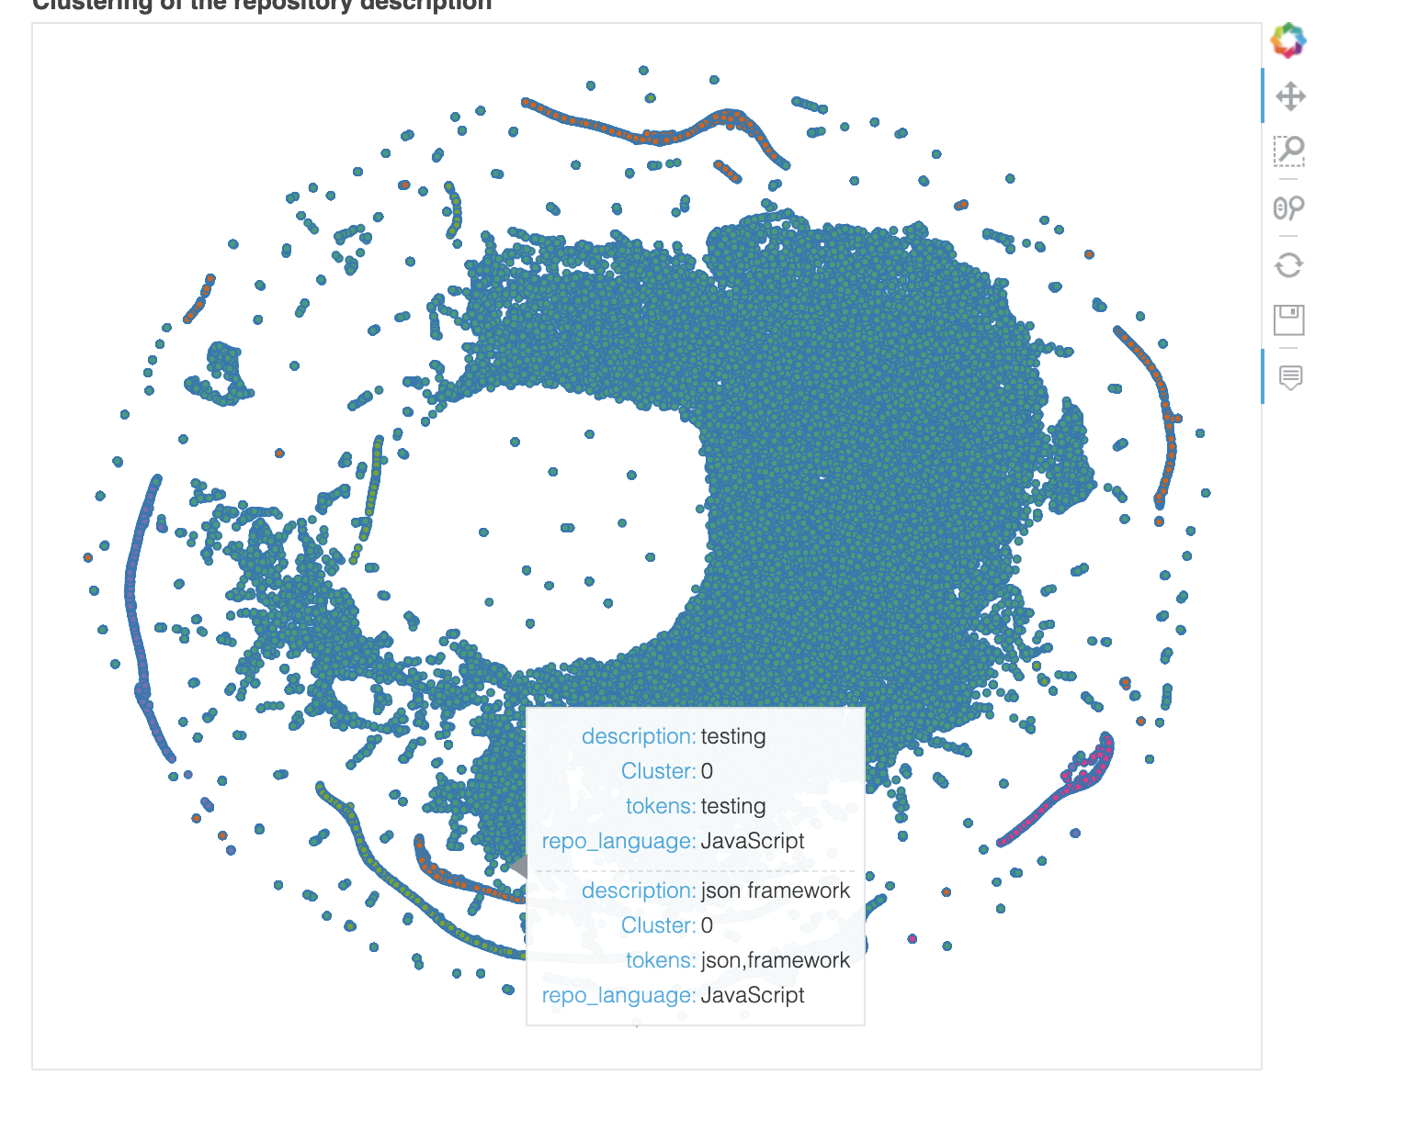

**Feature Engineering for Text Classification for predicting the technology.**

We will be classifying the repositories based on the descriptions into multiple technologies they were built using. Our target class is repository_language.

**Encoding the repository_language**

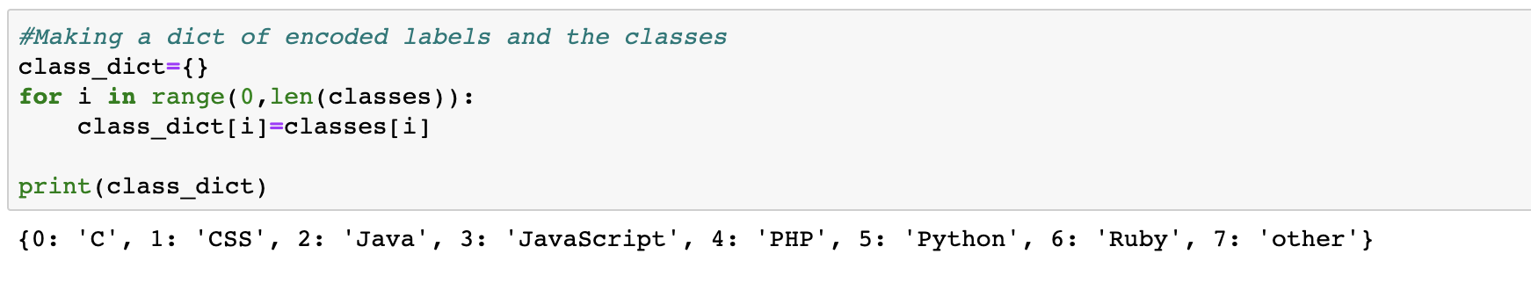

**Splitting the dataset into train and test:**

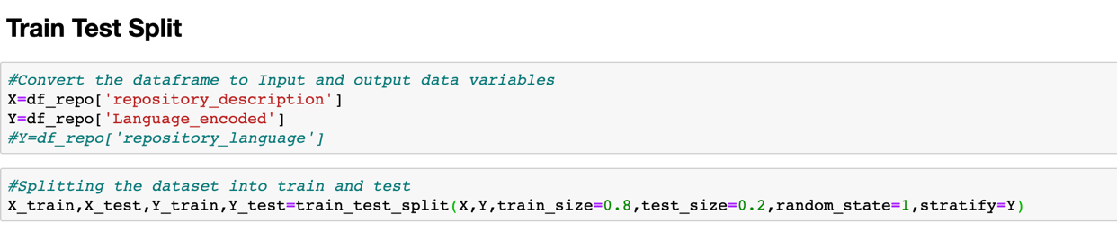

**Apply tfidf on the train and test dataset**

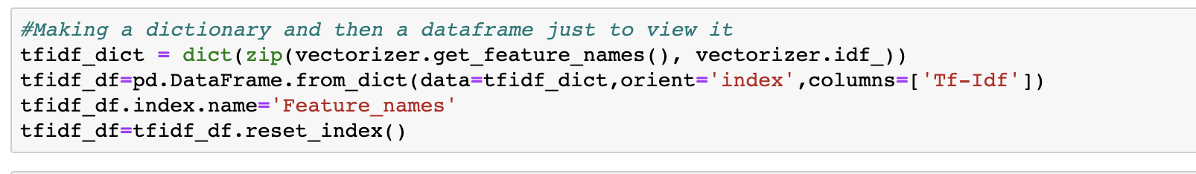

**Using chi2 test to determine the most significant and most correlated words with the target variable:**

The most significant features are whose value is less than 0.05. We have about 1842 features that are not correlated to the target.

Some of the non-correlated words are are ['wrapping', 'architecture', 'added', 'core library', 'smooth', 'sale', 'testing framework', 'plugin creating', 'parts', 'dynamodb', 'wars', 'tips', 'management tool', 'enhanced', 'simple interface', 'number', 'originally', 'closure', 'price', 'workflows', 'today', 'nice', 'import export', 'tutorials', 'conf', 'th', 'commit', 'ng', 'guest', 'column', 'websockets', 'engine written', 'temporal', 'heat', 'symbols', 'knowledge', 'console application', 'unique', 'drop', 'restaurants', 'verify', 'voting', 'vertical', 'provides simple', 'sqlite database', 'dispatch', 'playback', 'graduation', 'leap motion', 'room', 'pacman', 'repos', 'plugin provides', 'reference', 'sheet', 'upgrade', 'industrial', 'apex', 'real', 'pressure', 'edition', 'compressor', 'fullscreen', 'fonts', 'educational', 'winter', 'everyday', 'code related', 'velocity', 'moves', 'image gallery']

These features will not help us in predicting the technology of the repository.

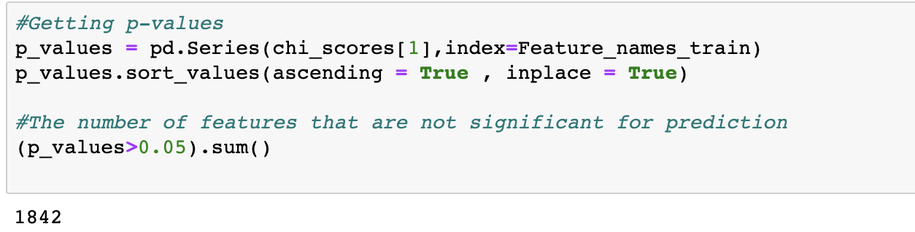

**The words that are most correlated to the target are:**

**1.'C' category:**

**Most correlated unigrams:**

**. nginx**

**. firmware**

**. pebble**

**. linux**

**. kernel**

**Most correlated bigrams:**

**. linux kernel**

**. kernel source**

**2.'CSS' category:**

**Most correlated unigrams:**

**. theme**

**. site**

**. personal**

**. blog**

**. website**

**Most correlated bigrams:**

**. personal site**

**. personal website**

**3.'Java' category:**

**Most correlated unigrams:**

**. spring**

**. minecraft**

**. bukkit**

**. java**

**. android**

**Most correlated bigrams:**

**. java library**

**. android application**

**4.'JavaScript' category:**

**Most correlated unigrams:**

**. angularjs**

**. nodejs**

**. jquery**

**. node**

**. javascript**

**Most correlated bigrams:**

**. chrome extension**

**. jquery plugin**

**5.'PHP' category:**

**Most correlated unigrams:**

**. laravel**

**. symfony**

**. plugin**

**. mirror**

**. wordpress**

**Most correlated bigrams:**

**. plugin mirror**

**. wordpress plugin**

**6.'Python' category:**

**Most correlated unigrams:**

**. xbmc**

**. sublime**

**. flask**

**. django**

**. python**

**Most correlated bigrams:**

**. written python**

**. python library**

**7.'Ruby' category:**

**Most correlated unigrams:**

**. activerecord**

**. cookbook**

**. chef**

**. rails**

**. ruby**

**Most correlated bigrams:**

**. ruby rails**

**. chef cookbook**

**8.'other' category:**

**Most correlated unigrams:**

**. website**

**. clojure**

**. haskell**

**. scala**

**. emacs**

**Most correlated bigrams:**

**. plugin mirror**

**. wordpress plugin**

**Model Training:**

We will be using the following machine learning classification techniques to predict the repository-language.

1. **Baseline Classifier**
2. **Random Forest**
3. **BaseLine Classifier**: Baseline classifier for my model will be the majority class that is JavaScript which is encoded as 3. The accuracy for the majority class would be 36 percent because it is 36 percent of all the data.
4. **Random Forest:**

I have fitted my data which has 500k rows and 5000 features to train random forest model. I went with the default parameters and it took about 111.69 seconds to train this model.

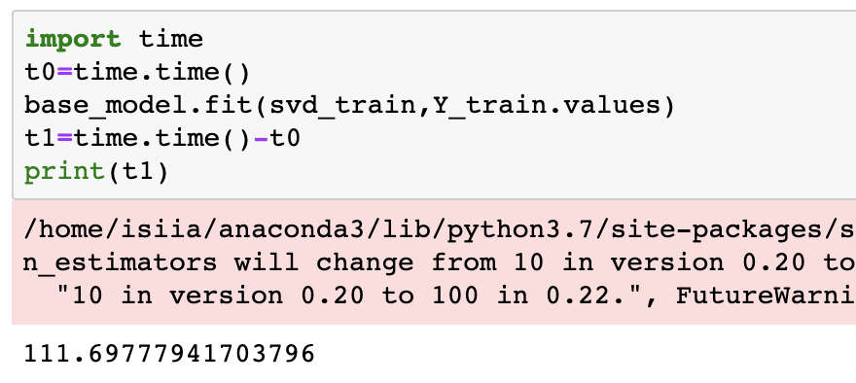

* I got training score as 75 percent and test score as 31 percent.

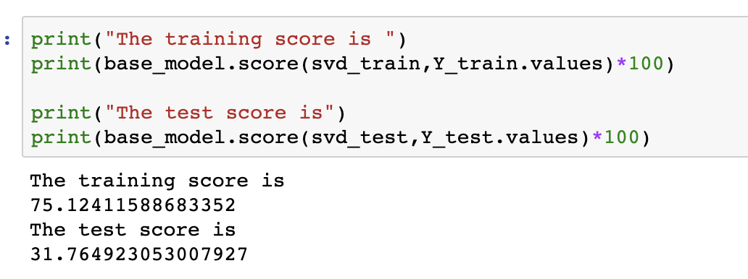

**As we can see in the above model there is a lot of overfitting and also the test accuracy is significantly very poor. To reduce the over-fitting we need to tune our hyper-parameters for Random Forest.**

**Tuning of Hyper parameters:**

**The most important hyper-parameters to be tuned are:**

* **N_estimators**
* **Max_depth**
* **Bootstrap**
* **Criterion**
* **max_features**
* **min_samples_leaf**
* **min_samples_split**

I have played around with the estimators and found that we have reduced over fitting by using

**base_model_new=RandomForestClassifier(n_estimators=200,max_depth=300,n_jobs=-1,min_samples_leaf=4,min_samples_split=4,warm_start=True,verbose=1)**

**For the above hyper-parameters, I got training accuracy as 54 percent and test accuracy as 51 percent.**

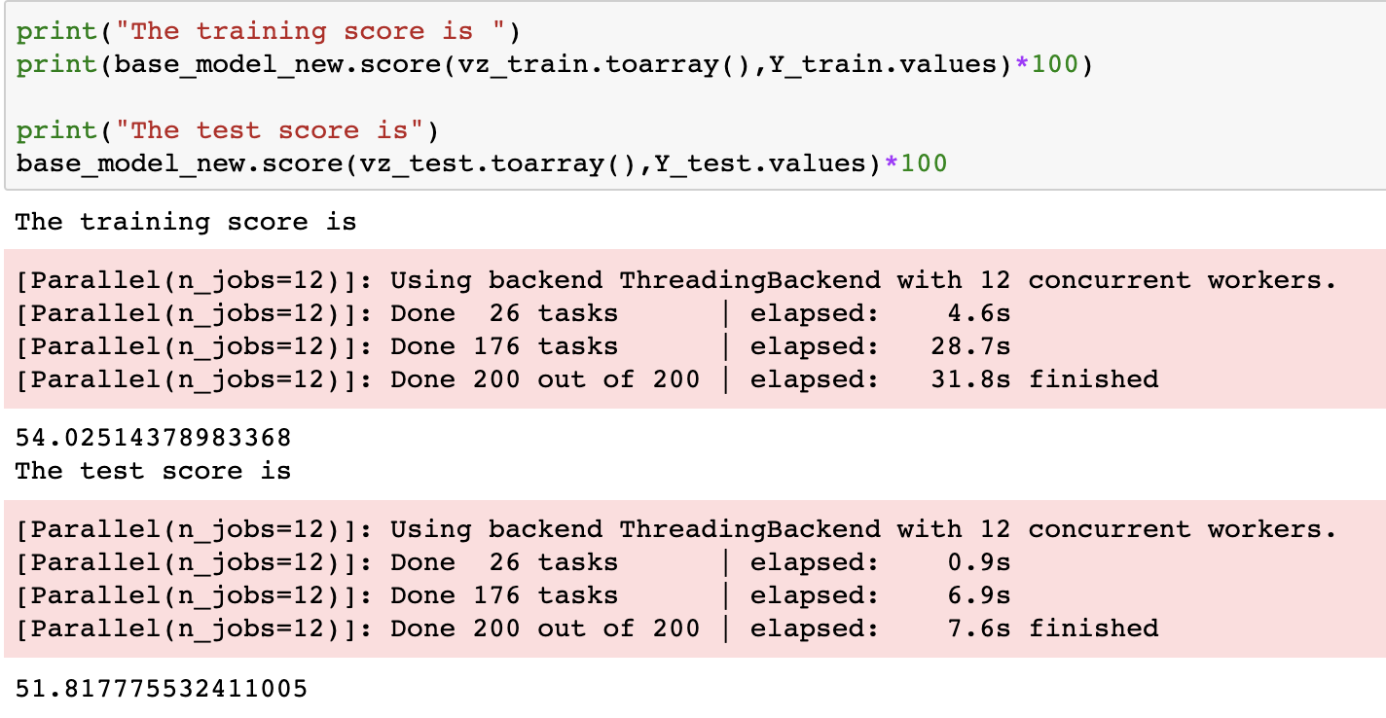

**By tuning the parameters, we have reduced the over-fitting and increased the test accuracy by 20 percent making it to 51 percent.**

Further by using cross validation and using the best parameters we can improve the accuracy of our model.

For doing the above we can use **RandomSearchCV** or **GridSearchCV for** model selection.

**Scope for improvement:**

* There is definitely a scope for improving the performance of this model. We can use other classification algorithms such as **XGBoost,SVM,KNN and Gradient Boosting** and see which one can fit better.
* We can find the best model by tuning their hyper parameters and using model selection algorithms such as **Hyperpot**.
* We can increase the prediction power of the model by adding more data.
* We can also use more features for training such as our Boolean and discrete features which we have not considered for model training along with the textual features.

**Conclusion:** As per our objective of our study.

* We have found out the groups in the repository.
* Identified Project Cluster which contain academic and student projects.
* Got the most correlated words to the repository languages.
* Built predictive model to classify the repositories into technical languages based on repository features such as repository description.